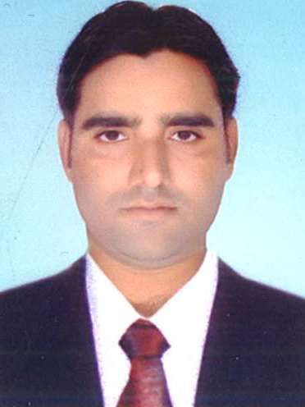
CURRICULUM VITAE

FIROZ

FIROZ.336880@2freemail.com

OBJECTIVE
Highly organized, having strong interpersonal communication skills. Acquired abilities to deal with people all levels in modern market and take independent decisions in high pressure environment very quickly. A confident self-starter with level of motivation towards acceptance and desire.
SKILL SET
- Ability to plan and prioritize work activities effectively
- Sincere and flexible to any work environment
- Highly disciplined
- Excellent team player and with resulted oriented
- Dedication, Sincere & Working are base
EDUCATIONAL ATTAINMENT
- Bachelor of Arts (from Zakir Husain P G College – Delhi University) 2010
- One year Diploma in Computer Application
Computer Skills
- MS Office, MS Word, Excel, Internet Explorer Etc…
WORK EXPERIENCE

- 6 month worked at a Personal Injure Claim in Glow Business Solution as a Claim Adviser International BPO UK Process.
- 4 years worked in Delhi Metro as a Customer Executive
- 1 year worked in Spenco Domestic BPO as a Customer Executive.
PERSONAL DETAILS

Sex : Male
Date of Birth : 01/02/1990
Nationality : Indian
Languages Known : English , Hindi & Urdu
Marital Status : Married
Visa Status : Visit Visa (Transferable)
PASSPORT DETAILS

Date of Issue : 29/09/2014
Date of Expiry : 28/09/2024

CONCLUSION
I hereby declare that the particulars given above are true to the best of my knowledge. If you provide me an opportunity, I shall work to the best of my ability in coherence with organizations mission and vision.

