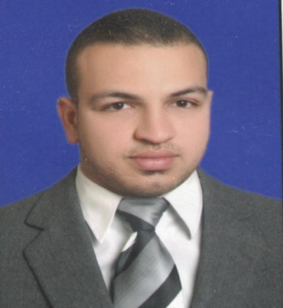
Bassem
Sales and Customer service specialist

Bassem.336947@2freemail.com

I
am a hard worker, self-motivated and passionate Sales and Marketing Specialist who is seeking a new challenge that can help me grow on both the personal and professional levels.. Having demonstrated good interpersonal and leadership skills and my ability to learn fast, I consider myself as a Self-Starter and Self-motivated with good ability to Solve Problems with excellent interpersonal skills and I have the ability to work under stress & pressure I’m Able to cope and react to changing situations, good in prioritizing.
Career objectives | - Sales  - Marketing  - Customer Service  - Distribution
Skills | Sales skills  Customer oriented skills  Communication Skills  Fast learner
Experience | Job title: Assistant Area manager  Company name: Union prime (Samsung and Huawei)  Date of employment:September 2015 -I currently work here  Responsibilities:  Out-said Distribution Representative, Distribute the Company products to traders, making the orders and follow up to achieving target  Job title: Assistant Store manager  Company name: Union group (Samsung)  Date of employment:September 2010 – Augt2015  Responsibilities:  In-said Sales Representative, Selling the Company products , responsible for applying the stock and the first line area (Retail and customer serves)  Job title: Sales Representative  Company name: Radio Shack(Mobile Shop)  Date of employment:February 2008- August 2010  Responsibilities:  Representing the company in the Store selling the Mobile phones, tablets and accessories.  Job title: Sales and Customer Service representative  Company name: Vodafone  Date of employment:November 2006- January 2008  Responsibilities:  Selling the products of the company (SIM cards "prepaid and post paid"-mobile phones and IT accessories) and I uses to be a Customer Service Representative when the customer had an issue regarding the company's products or the payments.
Education | Graduated from the Faculty of Physical Education(Alexandra, Egypt)2006
Languages | Arabic  English
Thank You

