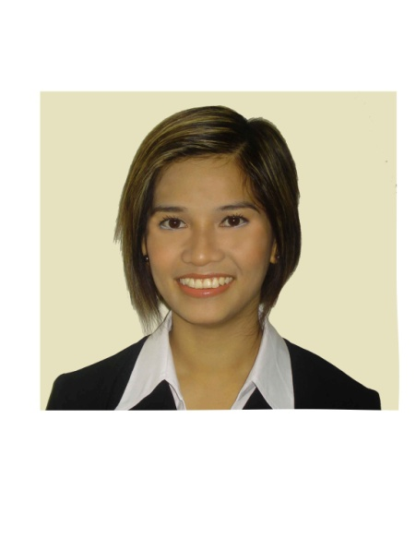
Hyacinth

Hyacinth.336969@2freemail.com

PROFESSIONAL SUMMARY
- More than 9 years in the field of hospitality in UAE and 7 years in music industry as a professional singer.
- Currently working as Human Resources Executive cum Personal Assistant to the Managing Director.
- Knowledge of Microsoft Office, EDNRD (online visa application system), Business Correspondence and Training.
INDUSTRIES: | Hospitality
FUNCTIONAL AREAS: | Human Resources, Public Relation Officer, Personal Assistant to the Managing Director, Trainer.

PROFFESIONAL EXPERIENCE:

HUMAN RESOURCES (PROMOTED)
Jumani Group of Companies
2014 – PRESENT

- Handled 130 employees.
- Prepared Payroll.
- Reviewed/approved department’s duty roster.
- Passport inventory
- Arranged transport and air ticket for staff.
- Applied Ikama (Residence visa) for all the staff
- Collected change status and exit stamps of ex-employees and filing for records.
- Filed documents related to employees manually and on the system.
- Advertised on job portals, screened CV’s, call candidates for interview
- Arranged/ Conduct staff initial training.
- Coordinates with different head of departments, regarding manning, job description and evaluation.
- Processed leave application/benefits of Hotel’s employees.
- Arranged documents for visa, medical and occupational health card for application or renewal submitted to Third Party Company.
- Arranged documents required for visa application / cancellation.
- Maintain and consult PRO for suggestions and advise anything related to staff visa and passport issues
- Issued and prepared termination letters to employees and preparing final settlement of employees.
- Monitored Hotel employee’s documentation validity.
- Issued memorandums, offer letters, certificates and other documents as requested and assigned.
- Prepare HOD minutes of the meeting to be circulated to all departments.
- Prepared employee of the month and birthday boards which includes the name and photographs of employees to motivate them.
- Kept cordial relation with the staff and be the first person of contact for queries related to HR.
PERSONAL ASSISTANT TO THE MANAGING DIRECTOR
Jumani Group of Companies
2007 – 2014

- Arranged visas/hotel reservation for the guest, family and friend of the Managing Director who intend to visit Dubai.
- Provide proper documents to the PRO for the submission, clearance of all kinds of visas (Tourists visa, Transit visa, Long visa and Employment visa)
- Submits visa details in Monthly basis to Accounts Department to monitor all the visa expenses of the Hotel, outstanding visa balance, and Hotel profit for the visa applied.
- Taking approval for all kind of documents to be signed by the Managing Director.
- Manages Managing Director’s day to day schedule and out of country booking & reservation.
- Devising and maintaining office systems, including data management and filing
- Provide general assistance to the Managing Director.
- Screening phone calls, enquiries and requests, and handling them when appropriate
- Meeting and greeting visitors at all levels of seniority
- Organizing and maintaining diaries and making appointments;
- Dealing with incoming email, faxes and post, often corresponding on behalf of the Managing Director.
- Write reports, executive summaries, Typing documents
- Conduct research on the internet, write minutes of the meeting
- Booked meetings or restaurant reservation for the Managing Director.
- Read, monitor and respond to the principal's email.
- Prepared correspondence on behalf of the Managing Director.
- Released Adds as per order of the Managing Director and scanning CV Sending updates and reports to the Managing Director especially if he is out of the country.
ACADEMIC QUALIFICATION

Stonebridge Associated Colleges United Kingdom, United Arab Emirates
Airline and Airport Customer care Certificate Course
2007

University of Perpetual Help System Dalta, Philippines
Molino 3, Bacoor Cavite
Bachelor of Science in Computer Science
2000

PERSONAL INFORMATION

Single, stands 5’3 in height. Born on June 30, 1979 at Manila, Philippines.
Speaks & Write English fluently / Tagalog .

