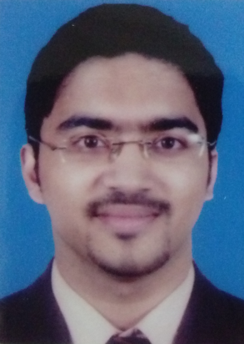
CURRICULUM VITAE

Kelvin Mathew Philip
_______________________________________________________________________
Objectives:
To obtain a respectable and responsible position in an organization which will enable me to use my talents, creativity and ability to the maximum and contribute to the growth of the Organization as well as myself.
Core Competencies
- Review and analysis of Standard Operating Procedures.
- Effective time management and multi tasking.
- Careful study and attention to detail.
- Ability to interact effectively and result oriented performance.
- Organized and professional in handling jobs.
- Possessing good team spirit in motivating others to perform better.
- Sincerity and dedication towards work and adopting ethical practices.
Work Summary:

- Worked as an Accountant Co.
(1st April 2010 - 31st October 2016)

  - Handling Petty Cash
  - Booking Monthly Journal Entry Expenses
  - Accounts Receivable
  - Accounts Payables.
  - Rental Credit Follow up with the Clients.
  - Meetings with the Legal Department on Monthly Basis and reporting to the Dept. Finance Manager and Group Finance Manager.
  - Monthly Bank Reconciliation.
  - Monthly Inter Company Reconciliation.
  - Reporting to the Finance Manager & Assistant Finance Manager.
  - Assisting the Finance Manager & Assistant Finance Manager with Audit Documents
  - Scanning & Filing the Documents up to date.
  - Accounting program used was ORACLE (ERP).

- Underwent training in the Accounts Department of Beverly Hills Real Estate Investment Company, Doha, Qatar. (July 2009 - December 2009)

  - Filing the Documents up to date.
  - Accounting program used was ORACLE (ERP)

- Underwent training in the Accounts Department of M/S Mannai Space
Travels, Doha, Qatar. (January 2009 – June 2009)
- Billing.
- Invoicing.
- Making Credit Notes.
- Refunding.
- Cross Check Reconciliation with the BSP Report and our Report.
- Filing.
- Accounting Software used was ORACLE.

Educational Background

No | Qualification | Board/University | Institution | Year of Completion | Percentage/GPA
1. | M.B.A | Philippines | A.I.I.A.S | March 2013 | 3.65/4.00
2. | B.Com | Mahatma Gandhi | Baselius College | October 2008 | 50%
3 | 12th Grade | CBSE | MES Indian School | March 2005 | 63.2%

Skills

- Completed Computer courses in M/S Family Computers, Doha, Qatar

- Excel
- Word
- Power Point

- Photography
- Customer Interaction
- Presentation Skills
- Client Relationship

General

- Tourism club coordinator of the Baselius College Kottayam, Kerala, India (2005-2006)
- Certified for Training in Customer Relationship Management held by the HR Management of Regency Group Holding, Doha-Qatar.

Personal Details

Date of birth : 07 August 1987
Marital status : Unmarried
Gender : Male
Nationality : Indian
Religion : Christian
Visa Status : Visit Visa
Languages Known : English, Malayalam & Hindi

Declaration

I hereby declare that above information is correct to the best of my knowledge and belief.

Kelvin Mathew Philip

Kelvin Mathew Philip – CV No 2021976

To interview this candidate, please send your company name, vacancy and salary offered details along with this or other CV Reference Numbers that you may have short listed from
http://www.gulfjobseeker.com/employer/cvdatabasepaid.php
addressing to HR Consultant on cvcontacts@gulfjobseekers.com

We will contact the candidates to ensure their availability for your vacancy and send you our service HR Consulting Fees quotation for your approval. Whatsapp +971504753686

______________________________________

