Curriculum Vitae

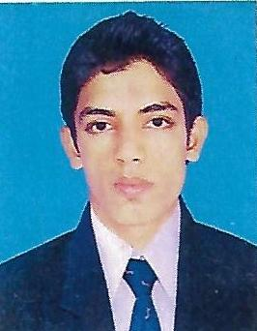
Samun
Samun.337001@2freemail.com
Career Objective:
To gain experience in the field ADMINISTRATION / Store Assistance .Intend to build a career with leading organization with commitment and Dedication ,which will help create an atmosphere for potentiality ,efficiency and elevation of the career.

Educational Background
- B com from MUMBAI University in the year 2014
- HSC from Maharashtra Board in the year 2009
- SSC from Maharashtra Board in the year 2007

Skill Sets
- Excellent communication skills
- Willingness to learn
- MS-Office .MS.CIT (Word, Excel, PowerPoint) Tally ERP 9

Operating System:
- Windows XP, Windows 7 Professional, Windows 8.1
Experience
- 6 month work Experience© Computer Operator From Mumbai university
- 1.4 year exp the Position Of clerk & cashier from DR A R UNDRE COLLEGE BORLI Till Date
Job responsibilties
- Receiving new computer hardware and then setting it up and installing it.
- Oversaw general computer operations
- Carrying out regularly scheduled uploads or downloads of data.
- Maintaining records of computer and system downtime.
- Handling inward and outward register.
- Cash received and account handling
- Maintain L C and Bonafied certificates

Extra-Curricular Activities:
- Part of the college cricket team.
- Represented school cricket team for inter-school competition.
- Participated in inter-school debate competition.

Personal Details
Date of Birth: 05/06/1993
Marital Status: Unmarried
Visa Status; visit visa
Visa valid ; 17/1/17 to 17/03/17
Nationality ; India
.

