SHEREEF

SHEREEF.337005@2freemail.com

Dear Sir/ Madam,
I have successfully completed my bachelor’s degree in Political Science from S N College, affiliated to the Kerala University, Kerala, India. And also completed my Diploma in IATA/ UFTAA Foundation course from IATS, Kerala,India affiliated to the Canadian University.
Being one of the most reputable companies in the industry , it would be a previlage for me to join your workforce. I am sure my leadership and communication skills, determined and hardworking nature will make me a integral parts of your company’s success.

CURRICULUM VITAE
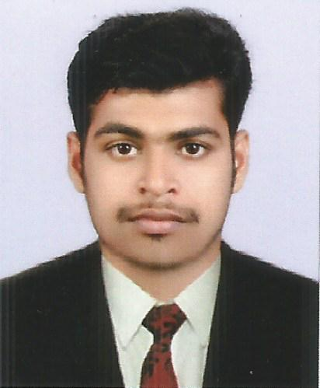
SHEREEF

OBJECTIVES
Obtain a position where I can contribute my experience in customer service field.I have very good customer service skills. I am detailed and organized worker. I have always punctual in my work and relied upon by my employer to guide other staff.

EDUCATIONAL QUALIFICATIONS
- Bachelor Degree in Political Science
- Higher Secondary Certificate
- Secondary School Leaving Certificate, Kerala

PROFESSIONAL QUALIFICATION
- Completed IATA/ UFTAA Foundation course

LANGUAGES KNOWN
- English
- Malayalam
- Hindi
SKILLS AND ABILITIES
- Good written, verbal presentation skill
- Able to get along well with co-workers and accept supervision.Received positive evolutions from previous supervisors
- Willing to try new things and am interested in improving efficiency on assigned tasks
- Concerned with quality produce work that is orderly and attractive.Ensure tasks are completed correctly and on time
- Invoice and inventory skills

PERSONAL INFORMATION
Nationality : INDIAN
Date of Birth : 04/01/1993
Marital Status : SINGLE
SEX : Male

PASSPORT DETAILS
Date of Issue : 17/05/2012
Date of Expiry : 16/05/2022
Place of Issue : Trivandrum

DECLARATION
I hereby declare that all the detailed mentioned above are true and benefited to the best of my knowledge and belief.

