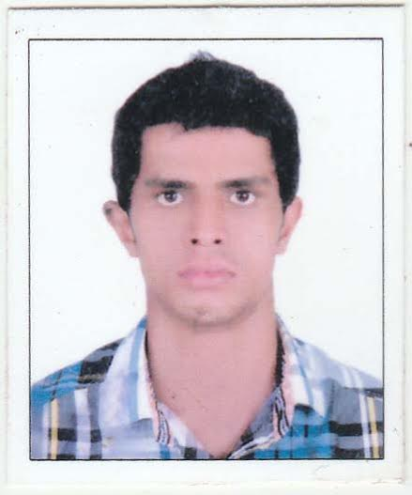
Nasim
Nasim.337009@2freemail.com

CAREER OBJECTIVE

Aspiring for a challenging role in your reputed organization where my competent technical skills& qualities as an experienced Mechanical Engineer, would contribute to the betterment of the organization.
EDUCATIONAL QUALIFICATION

- B.Tech Engineering Degree: Mechanical Engineering (2008-2012) from IES College of Engineering. (ISO 9001,NBA accredited & affiliated to University of Calicut, Kerala, India)
- Higher Secondary (XII) ICAEHSS (Kerala, India) _ 2008
- SSLC (X) GHSS (Kerala, India) _ 2006

PROFESSIONAL EXPERIENCE

MEDAC Private Limited (August 2014 to January 2017)
An Electro-Mechanical (MEP) Contractor Engineered by AL-AWAD Kingdom Saudi Arabia Located at Calicut, India.

- Work as MEP Engineer.
- Designing and installation of building mechanical systems (HVAC, Water service, Drainage,
Firefighting, medical Gases etc) using ASHRAE, National Plumbing Code ,Uniform Plumbing Code , NFPA etc.
- Installation and Maintenance of all Mechanical system such as HVAC ,Fire Protection Service and Plumbing etc in consideration with the contract , BOQ and relevant codes.
- Submit site daily reports, Inspection reports and all applicable monitoring reports on regular
Basis or as required.
- Planning and execution of site works.
- Expert in Microsoft Office Word and Office Excel tools.
- Ability to design and draft using Auto CAD.
- Coordination between Electrical, Fire Alarm, HVAC, Plumbing and Drainage systems using AutoCAD.
- Preparation of Shop Drawings and As built Drawings as per client requirements.
- Familiar with routing and sizing of different piping / ducting inside the building by coordinating with
other discipline.

DUTIES AND RESPONSIBILITIES

- Manage Project correspondence between client, design consultant, and sub-contractors.
- Co-ordination with client’s engineering team and Operation team for ensuring the proper implementation of day to day activities.
- Attending weekly/monthly progress meetings with client and consultants and prepare progress reports including reporting to company top management.

- Field visits with client to capture all critical construction issues during bidding for new projects.
- Manage, supervise the site & give report to project manager.
- Distribute the works among technical group as required.
- Arrange inspection of completed areas of systems & follows up the consultant
- Inspection and Quality assessment of installed mechanical installations on site.
- Control and manage the site staff.

PROJECT HANDLED

- King Faisal University (college of education building, Al Ahsa)
(Client- King Faisal University, Al Ahsa, Kingdim Saudi Arabia)

SOFTWARE EXPOSURE

- Auto CAD , Carrier HAP, McQuay Pipe Sizer

Bharath Petroleum Corporation Limited(March 2013 to July 2014)

A world renowned oil & gas company controlled by Indian Government.
Job Title :Mechanical Engineer
Project : Expansion the capacity of LNG Bottling Plant at cochin division.

RESPONSIBILITIES

- Manage Project correspondence between client, design consultant, and sub-contractors.
- Co-ordination with client’s engineering team and Operation team for ensuring the proper implementation of day to day activities.
- Attending weekly/monthly progress meetings with client and consultants and prepare progress reports including reporting to company top management.
- Prepare technical queries to client for missing or conflicting technical details in coordination with discipline engineers and propose modifications as appropriate.
- Preparation of technical submittals for Project materials.
- Handling of all Technical issues at site with client.
- Handled the commissioning of various field instruments like Pressure, Level, Temperature, Flow sensors, Shut down valves, Control valves, Gas detectors, Beacons, Hand switches, Manual call points.

PERSONAL DOSIER

Date of Birth : 30-04-1990

Marital status : Single
Nationality : Indian
Linguistic Ability : English, Hindi, Malayalam, Tamil
Hobbies : Chess, Football, Volleyball
Visa Status : Visit Visa

DECLARATION

- I hereby declare that the above furnished details are true to the best of my knowledge.

