Curriculum Vitae

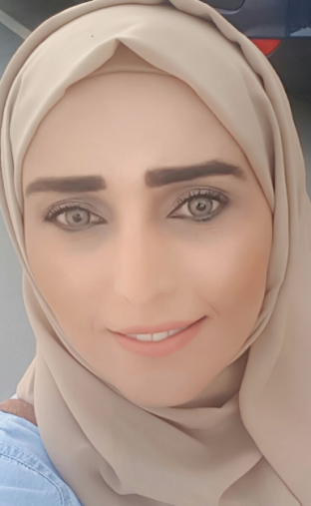

Personal Information:

Name: Seba
Date of Birth: 10/3/1979
Marital Status: Married

Nationality: Jordanian

E-mail: seba.337014@2freemail.com

Qualification:

MSC in HCM (Healthcare Management) Swiss Business School (2016-2017)
- Diabetes Educators Training Course from 18th Sep. 2011 - 15th Feb. 2012
- Valid BLS (Basic Life Support)
- Valid IELTS score.
- 2003: B.Sc. in Nursing; Jordan University of Science and Technology (J.U.S.T); Irbid, Jordan
- 1998: General Certificate of Secondary Education, King Hussein Secondary School/ Zarqa, Jordan.

Clinical Experiences:

Bourn Hall Centre, 30/12/01/2013 up to date.

Health and Diabetes Educator, and working with daily clinic management.

Responsible for the operations and administration side of a medical office. Ensures office is running smoothly by supervising office staff, and trains employees, and ordering medicines and dealing with companies for deciding medicines and instruments, generate inventory with the department, Delegate responsibilities..
Working closely with the management in managing the daily tasks at the clinic. I have good Experience at clinic healthcare management through my long experience at my work.

Diabetes Educator, Helping in clinics management.
Northwest Clinic for Diabetes and Endocrine

It’s become commitment as many of my colleagues to help in the prevention of Diabetes, to see all the patients in the world receiving the same quality of care regardless of any limitation.

Diabetes Educator.
Emaar Health Care
The Dubai Mall Medical Centre-
11th October 2009 until 15th January 2011.

-Supporting the diabetic patient, empower them to manage their illness and to cope with it.
-As Educator , we have to give them the help and support by ongoing process to achieve the needed behaviour changes , included training for all the skills to use the different devices needed in the management of the illness, insulin pump training, CGMS fitting and downloading, Carbs counting….etc

Diabetes & Endocrinology Coordinator,
Diabetes Educator
Wellness Medical Center
02nd June 2008 - 1st August 2009.

Duties and Responsibilities as Diabetic Educator

To assess and manage diabetic patients with special ability to identify complications.
To take a leading role in patients and family education.
To liaise with other healthcare personnel to ensure continuous efficient patient education and life style management.
- To maintain high standards of documentation of care and activities.
- To participate in the setting, monitoring and improvement of standards and the quality of patient care.
- To undertake and participate in specialist clinical supervision.
- To maintain a safe working environment.
- To provide information of present needs and future trends for service delivery.
- To demonstrate personal responsibility for compliance with infection control policies and procedures.
- To maintain record of own workload and performance monitoring information and review this on a regular basis.
- To actively participate in relevant national meetings/events to stay abreast of new developments and advances within the speciality area and feedback this information to the team to ensure continued learning and improvement to the service.
- To contribute to policy and protocol development for speciality area.
- To exercise a personal duty of care in relation to equipment, resource and stock control utilising equipment and supplies appropriately.
- To use advanced communication, counselling and interpersonal skills when delivering sensitive information, breaking bad news to patients and/or carers, or dealing with aggressive behaviour and contentious situations.

Endoscopy Department in charge and short stay unit,
Med care Hospital
20th Feb. 2007 - 1st June 2008,

Recovery room in charge

Emirates Hospital / Dubai, UAE
17th Oct. 2004 - 10th Feb 2007

IVF in patient In charge

Amman /Jordan

Farah Hospital / Amman, Jordan
4th Jan 2001 - 31st Dec. 2003.

Duties and Responsibilities:

- Experience coordinating IVF patients and procedures
- Preparing the pre op of the procedure and taking care of the post op.
- Responsible for whole VIP patients and celebrities.

Undergraduate Clinical Courses:

- ICU neonate, Jordan Hospital, Jordan/ from Sep. 2001 up to Jan. 2002.
- Maternity; Rahmah Hospital, Jordan for three months.
- Paediatric; Badea’ah Hospital, Jordan for three months.
- Medical surgical; Elementary Hospital, Jordan for three months
- Critical (Cath Lab, Heart ICU, etc); Al Arabi Centre for Heart and Surgery, Jordan for three months.

Personal Skills:

- Good communication skills.
- Team worker.
- Ability to learn and accept challenges at work

COURSES:

- Diabetes Education course in National Centre for Diabetes, Endocrinology and Genetics Jordan,
Amman for 2 weeks in May 2008.
- Computer Course in Microsoft office ,Excel , power point in July 2008
- IELTS Tests with overall score 6.5
- Valid BLS.(Basic Life Support)

Languages:

- Arabic: Mother tongue.
- English very good, spoken and written.

Holding valid UAE driving license.

PS.: more information available upon request

