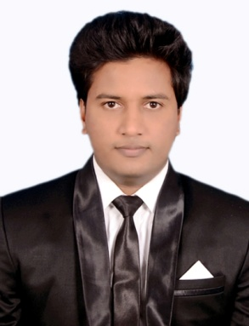
Mirza
Mirza.337061@2freemail.com

Career Objective
Looking for challenging duties in an expert environment that makes use of my analytical, problem-solving abilities, expertise and specialized development of my career and the business.

Profile Summary

- Cisco Specialist (CCNA) with 2 years experience providing
- Primary help desk technical assistance and troubleshooting an IT platform Setting up, configuration and organizations of CISCO IT infrastructure including, switches, routers, VOIP systems, QOS, security structures, firewalls and network protocols.

Work Experience
- System & Network Administrator, in Al-Badar Constructions.
- Responsible for generating and maintaining window server 2000/ 2003 /2008
- Microsoft Active Directory Architecture, Sites/Subnets, DNS, WINS, DHCP
- Assisted in hardware installation and maintenance of workstations, servers, networking equipment, and other supporting hardware.
- Performed user account creation, deletion, and configuration.

Certifications

- Cisco Certified Network Associate (CCNA)
- Cisco Id:

CCNA Engineer

- Manage connections ,configurations and organizations of CISCO equipment in IT architecture of organization
- Perform high level trouble shooting ,diagnostics for networking problems
- Provide support services for passwords recovery for network devices using system configuration registry
- Deliver support for remote access VPN and troubleshooting when necessary
- Support and provide solutions for network failures, making recommendations for possible fixes.
- Construct protocols for port security to prevent any unauthorized access to network.
- Co ordinate with team members to reduce technical complications sand collaborate on projects.
- Enabling port fast , uplink fast ,and backbone fast for fast convenience.

Key skills

- Outstanding customer services and client interfacing skills
- Ability to perform excellently on individual projects and cooperatively on teams.
- High adaptability and capable of handling high workloads.
- High capability and expert knowledge in Routing and Switching.

Achievements

- Best employee of month for 3 consecutive months in JQ
- Won chess tournament in sports day celebrated in office.
- Participated in programming competition during graduation.

Extracurricular activities

- Participated in various sports events.
- Participated in Annual Sports Day at school.
- Participated in various cultural events in School and Colleges

Education

- B.Tech (CSE) from “Jawaharlal Nehru Technology University”(TS) with 61% in 2010- 2014
- 12th Board of Intermediate with 68% in 2008-2010.
- SSC from Vijay Mary School, SSC Board with 73.6% in 2008.

Personal details

Nationality -- Indian
Gender -- Male
Date of Birth -- January 28th, 1993
Marital Status – Unmarried

