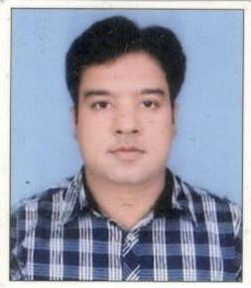
ABNEESH
Email: ABNEESH.337110@2freemail.com

JOB OBJECTIVE
Seeking a responsible position in an organization, which gives me a chance to improve Knowledge, enhance my skills.
ORGANIZATIONAL EXPERIENCE

Present Time working in Administration Department Uttar pradesh Lucknow, As a Office Assistant cum Computer Operator (2007 to till Date)
ACADEMIC CREDENTIALS

CLASS | BOARD | PASSING YEAR |  | MARKS |  | DIVISION
High School | Board of Higher Secondary Education, Delhi | 2005 | 379/600 |  | First
Intermediate | Higher Secondary Education Board, Delhi | 2007 | 356/500 |  | First
TECHNICAL CREDENTIALS

COURSE NAME | INSTITUTE NAME | PASSING YEAR | DURATION | MARKS | DIVISION | GRADE
Master Diploma In Computer Applications & Programming | Info Dot Training and Technical Institute, Lucknow | 2010 | 3 years (2008-2010) | 2317/3500 | First | B
Course On Computer Concepts | Wits Computer Institute, Faizabad | 2012 | 3 Months | - | - | C

HOBBIES

- Listing Internet Surfing, Listing Music, Watching News, Travelling, Reading Books.

IT SKILLS
- Proficient in MS Office Application

KNOWLEDGE

- Knowledge in Electronic Parts As a Work in (Printed Circuit Board (PCB) Sholding Create Circuit.
- Knowledge in Driving.

@
CORE COMPETENCIES

- Confidence and Dedication towards work
- Ability to Lead
- Adaptability and flexibility
- Strong interpersonal and organizational skills
- Keen desire of learning and sharing learning

REFRENCES
Available on Request

