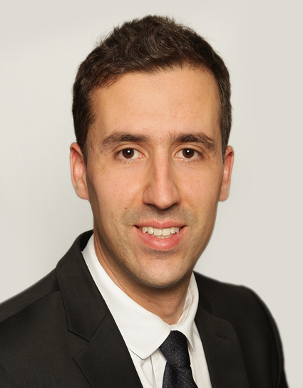
Oussama
Oussama.337116@2freemail.com

SALES ENGINEER
6 years experience

SKILLS
- Excellent in IT skills including MS power point presentation, Excel functions and Word
- Competent in computer science: Unix, Catia v5, Patran, Nastran, Femap
- IELTS English certificate (score B2 level)
- Mechanical engineering knowledge
- Sales and negotiation skills, building effective team, analytical ability

- Languages: English: Working proficiency
French: Bilingual proficiency
Arabic: Native proficiency

EMPLOYMENT HISTORY
2015 - 2016 Store manager at Opulent perfumes (1 year)
London – UK

“Opulent perfumes” is a retail trade company based in London, which sales different middle-eastern luxury perfumes brands. The store is located at Westfield shopping centre, the biggest shopping centre in Europe. During one year working, I increased turnover (£400K) of 15%.
My duties were:
- Sales of middle-eastern luxury perfumes and meeting target sales
- Overall care of staff and their well being
- Recruiting, workplace scheduling
- Handling customers issues or queries

2012 - 2015 Mechanical engineer at EXcent Group (4 years)
Colomiers – France

“Excent group” is an industrial group based in France, specialized in manufacturing handling tools for the aeronautical industry. The main principal customers were Airbus, EADS and Safran group. I worked four years for them and gained experience in sales negotiation and mechanical studies (metallic and aluminum structures, stress calculations, FE method).
My duties were:
- Sales of industrial handling tools for aircraft’s turbines (1-3 tonne/tool , €5-20K/tool)
- Interpreting customer requirements and specifications
- Analysing costs and sales
- Calculating client quotations
- Mechanical study (Finite element method)
- Meetings with clients, negotiation
- Technical presentation

2011 Sales representative at Cyberfix31 (1 year)
Toulouse – France

“Cyberfix31” is a retail trade company based in France which sales laptop computers, mobile phones and all additional accessories. During one year working, I increased turnover (€200K) of 20%.
My duties were:
- sales of laptop computers and mobile phones
- Meeting target sales
- Customer service
- Write quotes

EDUCATION
2008 - 2010 Master’s degree in Mechanical engineering
Paul Sabatier University – Toulouse/France

2004 - 2008 Bachelor’s degree in Mechanical engineering
Paul Sabatier University – Toulouse/France

INTERESTS
- Impact of nutrition on physical performance as a preventive therapy
- Frequent swimming and jogging
- Traveling (UK/1year, Dubai/1year, Jordan/5years, Saudi Arabia/4years, Morocco/2weeks, Tunisia/2weeks, Turkey/2weeks)

REFERENCES
Available on request

