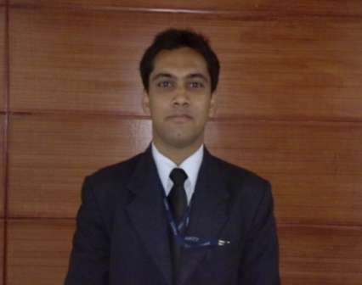

NAIM

NAIM.337129@2freemail.com

Objectives:
Seeking a Job that will explore and utilize my Knowledge, Skills and Abilities, which would allow me to share my experience and learn more. To Develop and become a better and more mature individual with good career prospects.

Personal Information:

Date of Birth: 16th August, 1984

Marital Status: Single

Sex: Male

Age: 31 Years

Nationality: Indian

Language Known: English, Hindi, Urdu (Reading, Writing & Speaking)

Visa Details: Hotel Employment Visa

Hotel Industrial Training:
- Completed my Industrial Training from Courtyard By Marriott (Gurgaon) of five month in all major department like Kitchen, Food & Beverage, House Keeping, Front Office and H.R with the rating of EXECLENT trainee among my batch.
- Completed my Vocational Training form Trident Hotel a group of Oberoi Hotel (Agra)
Working Experience:

Somewhere Group of Hotels 4*

DIVISION: Food & Beverage Department

CONCEPT : Causal Dining & Room Dining
LOCATION : AL-Barsha Heights (Dubai UAE)

DESIGNATION: Food & Beverage Associate (From 24 April – Till date)

- Waiter ( Acting Captain ).
- Responsible for smoother functioning of Restaurant & Room services.
- Interacting with customers and understanding their requirement.
- Making individual daily targets.
- Checking the Sale report entering the data into system & mailing to Manager.
- Maintaining store request
- Checking incoming & outgoing stock.
- Multinational Customer Base.
- Daily interacting with F&B Manager
- Managed customer complaints and feedback for constant improvements
McDonalds Family Restaurant

DIVISION: Restaurant Operations

CONCEPT : Dine In, Take Away & Mc Delivery
LOCATION : Delhi, India.

DESIGNATION: 2nd Assistant Manager

- Responsible for smoother functioning of the store.
- Interacting with customers and understanding their requirement.
- Making individual daily & monthly targets for each sale executive.
- Giving products knowledge to staff.
- Checking incoming & outgoing stock.
- Entering stock into system.
- Multinational Customer Base.
- Daily interacting with Store managers, Operation heads in the HO for new promotions, New stock.
- Motivating the sales staff & working on their productivity.
- Giving them training on their weak points & increasing the productivity.
- Managed customer complaints and feedback for constant improvements

Zuhor Group

DIVISION: Zaroob Restaurant Operations

CONCEPT : Dine In & Take Away
LOCATION : Global Village UAE.

DESIGNATION: Cashier (19 Nov 2015 –Till Date)

- Responsible for smoother functioning of the store.
- Interacting with customers and understanding their requirement.
- Making individual daily & monthly targets for each sale executive.
- Checking the Sale report & Entering into the system
- Checking incoming & outgoing stock.
- Entering stock into system.
- Multinational Customer Base.
- Daily interacting with Brand managers.
- Motivating the sales staff & working on their productivity.
- Giving them training on their weak points & increasing the productivity.
- Managed customer complaints and feedback for constant improvements
Area Of Interest:
- Fast Food & Beverage
- Customer Service
Achievements & Awards:
- Winner of the McDonalds prestigious award ‘The Golden Hat ‘for the Best Manager among my batch.
- Winner in Annual Fest – ‘Chef De Potage’ at BBD University – Lucknow, India.
- Winner of the Amity Annual Event ‘ Samanway Snap Deal’
- Winner of Dominos Junior Pizza making competition.
Educational Background:
Name of School | Board/University | Period | Class/Grade
 |  | From To
Amity School of Hospitality, Lucknow | Amity University | 2010 2013 | First Class

Additional Qualification:
Basic Course in Computer Application well versed with MS-Word, Excel, PowerPoint, etc;

Skills:
- Consistent
- Hard working
- Result Oriented
- Optimistic
- Exemplary organizational and communication skills.
- Exceptional Interpersonal Skills.
- Analytical Reasoning and Data Analysis skills.

Trainings attended:
- Shift Management Excellence Course – McDonalds.
- Advance Shift Management Course – McDonalds.
- Effective Management Practice Course – McDonalds.

Courses Included trainings on the below:
- Retail selling skills
- Interpersonal skills
- Team Building
- Various Product Trainings
- Customer Complaint Handling
- Advanced Customer Service Training
- Inventory Management
- Scheduling Management
- Food & Safety Management
- Planning Daily Maintenance

