CURRICULUM VITAE 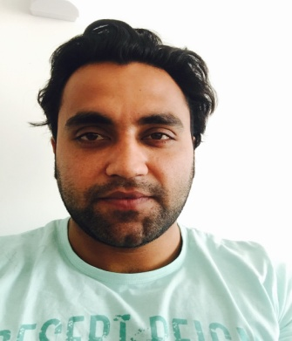

SHEHZAD
SHEHZAD.337134@2freemail.com

CAREER OBJECTIVE

To work in an organization where there is exclusive environment, healthy competition and ample prospects of professional growth. Where I am exposed to all types of work fields, can enhance my knowledge and broaden my experience to the maximum. In short I just want to be the active part of development.

STRENGTH & SKILLS

- Fast learner willing to shoulder challenges and responsibilities.
- Maintain confidentiality while handling departmental related activities.
- Strong verbal and personal communication skills.
- Self motivated, initiative, high level of energy.

WORK EXPERIENCE

- Worked as Site Engineer in Creative + Karkon Company–Pakistan.
(2013 to 2015)
- Worked as Auto Cad Draughtsman in Brains College of Peshawar kpk-Pakistan (2012-2012)
- Worked as Manager In Khyber Hotel-Pakistan (2015-2016)

- JOB PROFILE

- Acknowledged for strengthening relationships with Banks, Auditors, Consultants, and senior management of company by maintaining relationships, fund raising and stabilization of processes.
- Excellence in coordinating with external agencies for techno-commercial negotiations, preparation of contract documents, renewals, cost estimates, claims and so on
- An effective leader with excellent communication, negotiation and relationship building skills
- Reviewed the sales and cost tariffs and made necessary changes to be competitive in the market
- Automated the preparation of 10 reports using Spread Sheet that had previously required 6 hours of effort per week
- Liaised with management on daily/weekly basis the financial position of the company and to suggested suitable action plan
- Collaborated with the senior management in identifying balance sheet risks; represented the Financial Controller, achieved savings of US$ 100 Thousand
- Improved the timeliness of month-end financial reporting from approximately 20 to 10 days
- Initiated an income and expense flux analysis for the first working day of the month that provided for early identification and correction of posting errors; these efforts contributed to accelerating the month-end close to the Tenth calendar day of every month

ACADEMIC QUALIFICATION

- DAE CIVIL -ASSOCIATE ENGINEER (2011-2014)…GPA 78% A grade.
- MATRIC – Open Cast mining and Quarrying – CESECO (2010-2011)…GPA 70% B grade

COMPUTER SKILLS

- Auto Cad (3d)
- Typing ( 30 WPM)
- Eagle Point
- Installation of Various Software and Hardware Trouble Shooting
- Internet Surfing
- M.S. Windows XP 7,8
- M.S Word
- M.S Excel
- M.S Access

Filed of Interests

- Civil Engineer + Surveyor
- Airport Management & Staff
- Hospitality

LANGUAGES KNOWN

- English (Speaking, Listening, Reading & Writing)
- Urdu (Speaking, Listening , Reading, Writing)
- Hindi (Speaking, Listening)

HOBBIES & INTREST

- Playing Cricket
- Browsing Internet
- Maintain Good Relation with others
- Gym

PASSPORT DETAILS

- Date of Issue : 11/11/2015
- Date of expiry : 09/11/2020
- Place of Issue : PAKISTAN

PERSONAL INFORMATION

- Date of Birth : 15/03/1995
- Gender : Male
- Nationality : Pakistan
- Marital status : Single

DECLARATION

I hereby declare that the above entries given are true and correct to the best of my knowledge and belief

