Omar
Omar.337137@2freemail.com 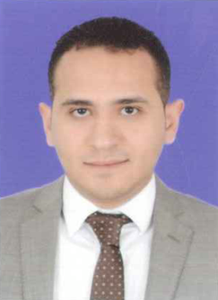
Profile:
A result-driven, articulate and well-presented Sales Consultant with a proven track record of meeting store sales targets and minimizing stock losses. Hardworking, able to communicate effectively with people from all backgrounds and able to present products in a structured professional way face to face with customers. Comfortable
working in a fast-paced, growth orientated work environment and have global experience of selling fast moving costumer service , consumer goods (FMCG), clothes and furniture and real estate in and outside Egypt.
Education:
B.Sc. of commerce, Accounting, Department, Al Azhar University, May 2006
GPA: Good
Professional experience
- 03-2015 – 09-2016
Sales Executive at Mishwar Group Co. Real Estate Dep. , Saudi Arabia
Key responsibilities
• Advertise for lease or rent on the property, select tenants, make rental or lease agreements, collection of deposits and rent, solve tenant issues, and oversee eviction in case of rent agreement violation scenarios.
• Negotiate property sales contracts, scheduling its maintenance, managing building maintenance projects; compile all data for financial reports by regularly maintaining and updating all records and files.
• Follow up on the complaints, disturbances and violations of the tenants and assists to resolve problems and provide optimal level of service, following management rules and regulations.
• Handle all financial operational aspects of property like rent, property taxes and maintenance.
• Update the company about the physical condition of the property, and all financial arrangements.

• Marketing and analyzing vital information about government zoning rules and regulations, future property values, and other pertaining tasks around the property.

• Maintain system database of potential customers and a list of competitors.

- 05/2010 – 10/ 2014
Assistant Store Manager at Ali Abdul Wahab commercial co., Kuwait

- 06/2008 – 05/2010
Sales Associate - Sales at Alshaya co., Kuwait

- 01/2007 – 12/2007
Customer Service Agent at Vodafone co., Egypt

Training Courses
- Jan 2014
HR Management Diploma, (30 hrs.)
NGC Academy Accredit by Cairo University, Egypt

- Feb 2012
- ICDL Course, (30 hrs.)
Russian Culture Center, Egypt
- June 2009
Advanced English Course (36 hrs.)
American University in Kuwait (AUK), Kuwait

Skills
- Languages
Mother Language: Arabic
First Language: English

- Computer Skills
- Excellent command of using MS Windows, Outlook, Word, Excel, Power Point, and Internet applications (www, ftp, social networks)
- Excellent command of using ERP solutions (Oracle, Double Click)

- Personal Skills
- Excellent communication Skills
- Leadership Skills
- Self-Motivated
- Fast Learner
Additional Data:
Date Of Birth : 31 May 1983
Military Status : Exempted
Marital Status : Married
Nationality : Egyptian
Driving License : Saudi, Kuwaiti, Egyptian
Gender : Male
Reference
To be furnished upon request.

