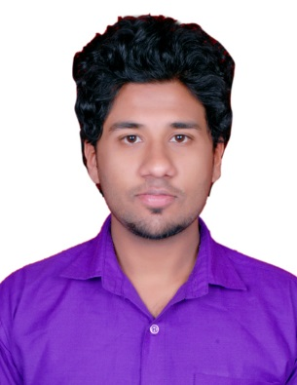
Aswin

Aswin.337141@2freemail.com

To obtain a challenging and rewarding position in IT Business Intelligence /ERP with an organization which recognizes my true potential and provides me sufficient avenues for professional growth through nurturing my technical skills and competencies.

PERSONAL INFORMATION

D.O.B: 11th January 1992
Citizenship: Indian
Marital status: Single
Sex: Male
Linguistic Proficiency: English, Malayalam, Tamil, Hindi, Kannada

A quick summary.

Graduate in information technology.
Excellent administrative and social skills.

Knowledgeable and hands on expertise on technological /CRM/ERP
leadership skills and proactive.

WORK HISTORY
feb 2015 – jun 2016 Hi-Power solutions, bangalore
Senior E-Commerce ERP Associate
.Roles.
* Being Knowledgeable of all the Credit cards and cashing Policies, and How to Handle Cash properly and efficiently.
* Develop Detailed Knowledge and genrating reports
*Develop a working Knowledge of the Reservation Department, Take same day reservations, and be aware of the cancellation procedures.
*Understand and use properly the Mail, Parcel, Message Delivery.

OCT 2013 – FEB 2015 INFOSYS, Bangalore

ERP/HR ASSOCIATE
1)Assist with day to day operations of the HR functions and duties
2) Provide clerical and administrative support to Human Resources
3) Coordinate HR projects (meetings, training, surveys etc)
4) Coordinate communication with candidates and schedule interviews
5) Conduct initial orientation to newly hired employees

- Infosys, The Business Process Outsourcing subisdary of Infosys Limited, is an end- to - end Out sourcing services provider.Infosys BPO addresses clients business challenges and unlocks business value by applying proven process methodologies, integrated IT and business process outsourcing solutions.
- Working under the Banking Financial Services and Mortgage Insurance vertical (BFSI).
- .Networking support.
- Responsible for the installation of Operating System, application software, assembling & General fault finding of software, & hardware.

Jan 2013 – apr 2013 wipro, bangalore
Engineer Trainee
- Extensive training on IBM Cognos 8 Business Intelligence Application besides DWH,SQL and Cognos.

EDUCATION

JUL 2009 – MAY 2012 Nettur tECHNICAL Training FOUNDATION
INFORMATION TECHNOLOGY
- Passed with an aggregate of 70% grade.

JUL 2010 – MAY 2013 aNNAMALAI UNIVERSITY
BAchelor of Science in INFORMATION TECHNOLOGY
- Passed with an aggregate of 75% grade.

JUL 2007 – MAY 2009 KVHSS
12th COMMERCE
- Passed with 60.5% marks.

JUL 2006 – MAY 2007 BEMP
10th
- Passed with 73% marks.

NETWORKING SKILLS

- Network processing, centralized and distributive network connection
- Installing, configuring and administering network technologies
- Ample knowledge in Windows 98 \ Me \ XP \ 2000 \ 2003 Server\2008 Server\Linux Server
- Active directory management, NTFS security, disk quota management
- Good understanding of OSI Model, TCP/IP protocol suite (IP, ARP, ICMP, TCP, UDP, RARP, FTP, TFTP).
- Well understanding of Bridging and switching concepts and LAN technologies
- IP addressing, sub netting and routing concept.

STRENGTHS

- A high tolerance of stress and enjoys responsibilities
- Quick learner with good grasping ability
- Action-oriented and result focused

