Qussai
Qussai.337204@2freemail.com
(Human Resource Management Professional)

Personal Statement:
I am a quick learner, active with excellent communication skills. I appreciate and respect workplace environment. I pay attention to details and enjoy working in teams. My strengths can be abbreviated as SMART:
S= Self-Motivated
M= Marvelous
A= Authentic
R= Reliable
T= Timed

Contact Details:
Dubai
United Arab Emirates
(Mobile)

Achievements:
- KPMG BRAVO Award winner for Q1 and Q3 in 2016
- Rated as “Highly Effective Performance” in 2016

Educational Background:
2015: MBA in Human Resource Management
Currently pursuing (CGPA: 3.80 out of 4.00) = 95%
Canadian University of Dubai - UAE
2009-2013: BBA in Human Resource Management
(CGPA: 3.92 out of 4.00) = 98%
Summa Cum Laude (Highest Honors Degree)
Canadian University of Dubai - UAE

2009: High School Certificate (Stream: Science) – AVG: 95%
Al Rashid Al Saleh Private School – Dubai, UAE
Working Experience:
((1)) Full-time Job:
Company Name: KPMG Lower Gulf Limited
Job Title: HR Associate
Period: From Dec 2014 to Present
Main Responsibilities:

- Managing the CPE sheet for both UAE and Oman.
- Analyzing feedback forms for various training programs that happen internally and externally.
- Structured the induction program and developed the new joiners’ experience.
- Managing the staff list.
- Managing the petty cash of the HR department.
- Conducting employee satisfaction surveys across the year.
- Managing the KSSC (KPMG Shared Services Center) requests that come to the L&D function.
- Shortlisting candidates from KPMG’s career portal for the UAE practice.
- Headhunting through LinkedIn.
- Managing the career portal (posting, editing, and deleting) requisitions as per the business requirements.
- Preparing executive summaries and descriptive reports about the HR department’s standing case.
- Keeping and maintaining the L&D folders.
- Preparing yearly and triennial compliance reports for our professional staff.
- Making studies and researches related to people’s area in the workplace.
- Developing external and internal clients’ relationships to achieve the organizational MANTRA and objectives.
- Assisted and attended the (Ace the Case) annual competition for two consecutive years.
- Played a major role in KICC (KPMG International Case Competition) both behind the scenes and onsite.
- Managing and attending career fairs and campus events.
- Coordinating overseas technical interviews.
- Conducting, correcting, and developing assessments for potential candidates.
- Managing several last-minute projects perfectly.
- Involved in various engagement programs starting from employee attrition reaching employee retention.
- Coordinating trainings and seminars.
- Assisted in KPMG graduation ceremony.
- Managing the department’s CSR events.
- Managing the social events and global days for the firm.
- Managing wellness days for the firm.
- Assisting in creating and issuing the internal HR newsletter.
- Assisting in the internal rewarding program that rewards exceptional performers.
- Conducted several researches and studies for the top management. (Diversity and inclusion, various generations in the workplace, and attraction & retention)
- Preparing reports for “The performance development process” which is taking place thrice a year. (Setting goals, mid-year review, and year-end review)
- Driving various engagement initiatives to increase and boost the energy levels for our staff.

((2)) Full-time Job: (Project)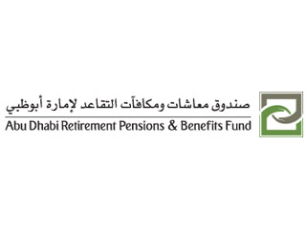
Company Name: Abu Dhabi Retirement Pensions and Benefits Fund
Job Title: System Analyst
Period: From Aug 2014 to Nov 2014
Main Responsibilities:

- Analyze data and information about the contributions and additional pensions.
- Convert binary data into useful Information.
- Analyze the tables of the contributions for further amendments.

((3)) Full-time Job:
Company Name: Systems Middle East L.L.C
Job Title: Technical Pre-sales Executive
Period: From Aug 2013 to Jul 2014
Main Responsibilities:

- Implementing, supporting, and enhancing ERP systems.
- First line of support for technical issues.
- Attend conferences and meetings for Business Development.
- Attract clients to invest in our ERP systems.
- CRM.
- We delivered the project of "Nakheel" professionally by installing the system that serves and supports their millions of apartments and residential units.
((4)) Internship: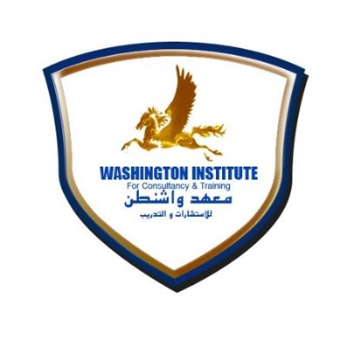

Company Name: Washington Institute for Consultancy and Training
Job Title: Training Coordinator (Internship)
Period: From Jun 2012 to Sep 2012
Main Responsibilities:

- Telesales
- Administrative Tasks
- Training Coordination
- Training Supervision

Other Certificates and Training Courses:
- IELTS (6.0)
- CFM (Certified Financial Manager)
- IC3 (Internet and Computing Core Certification)
- Acting with Integrity
- Independence Training
- Data Privacy Training
- Branding Workshop
- Crucial Conversations
- Business Etiquette Training
- Advanced Excel Workshop
Computing Experience:
- Global Resourcing System (KENEXA)
- Windows 8
- Farvision ERP system 2013
- Peach tree Complete Accounting 2005
- QM for Windows 3
- MS Word for Windows 2007 – 2010
- MS Excel for Windows 2007 - 2010
- MS PowerPoint for Windows 2007 – 2010

Language Skills:
- Arabic: Fluent orally and written (Mother tongue)
- English: Fluent orally and written
- Turkish: Satisfactory
- Russian: Basics

Interests:
*Football, Jogging, and Writing Poems.

Personal Information:
Date of Birth: 6th of September 1992
Religion: Muslim
Nationality: Jordanian
Gender: Male
Marital Status: Married
Driving License: Yes
Visa Status: Employment Visa (Free Zone)

References:
*Provided upon request.

