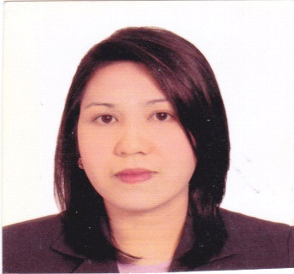

LALYN

LALYN.337209@2freemail.com

Career Objective:
- To contribute my acquired experiences in your organization’s operations as well as part of your vision.

Special Skills and Interest:
- Able to read, write and verbally communicate in English.
- Proficient in basic computer such as Ms-Word and Ms-Excel.
- Can work under time pressure and or deadline.
- Likes serving people.
- Accepts direction easily and willing to invest and effort to complete certain responsibilities.
- Always wear a smile.

Work Experience:
Famous Amos (Deli & Meal LLC)
Samha, Adnoc Station Abu Dhabi, U.A.E.
January 11, 2013 – February 25, 2017
Sales Associates
- To assist in the day to day operation of the store such as cashiering, customer service, stock ordering, baking and housekeeping.
- To ensure achieve sales target with excellent service standards.
- Make variety of coffee such as latte, espresso, cappuccino, and americano.
- Making gift hampers.
- Make sure that each customer leaves the store satisfied with the service.

Al Shamaliah Company
Sharjah,UAE
February 16, 2009- March 31, 2012
School Attendant
- Maintaining cleanliness at the assigned area.
- Prepares food in the canteen.
- Makes inventory.
- Performed other duties that maybe assigning from time to time.

SM Megamall Department Store
Mandaluyong City, Philippines
May 2005- February 2009
Sales Associates
- Always apply the importance of “Excellent Quality Service” especially to the customer itself.
- To be able to maintain cleanliness of the merchandise.
- Always maintain the stock level of merchandise especially in the selling area.
- Always apply the basic method of “FIFO” (First In First Out) of the merchandise.
- Always bear in mind to reach the highest target quota.

The Landmark
Makati, Philippines
August 2004- April 2005
Sales Associates
- To welcome the customers by your smile and greetings.
- To assist the needs of the customers.
- To promote the product that you’ve been assigned.
- Keeping and recording all the inventory items on up to date basis.

Educational Attainment:

Computer Secretarial
Silay Institute
Silay City Negros Occidental, Philippines
1999- 2001

Personal Information:

Date of Birth : June 18, 1981
Marital Status : Single
Gender : Female
Citizenship: : Filipino
Language Spoken and Written : Filipino and English
Visa Status : Transferable Visa

I hereby attest that the above information is true and correct to the best of my knowledge and belief.

