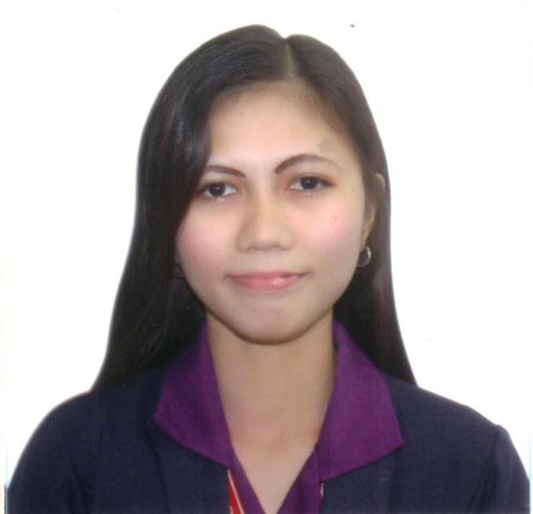
RAQUEL
RAQUEL.337216@2freemail.com
LUNTAL, TAAL, BATANGAS

______________________________________________________________________

CAREER OBJECTIVE:

To be able to apply and impart the knowledge I have obtained from my studies on the task that will be assigned to me and develop everything I learned as well as my skills.
_____________________________________________________________________

HIGHLIGHTS OF QUALIFICATIONS:

- Hardworking and responsible
- Ability to work in a team
- Can communicate both English and Filipino
- Computer Literate
______________________________________________________________________

EDUCATIONAL BACKGROUND:

TERTIARY: Batangas State University
Rajah Matanda St. Bagong Sikat, Lemery, Batangas
2014-2015
Bachelor of Science in Accounting Management

SECONDARY: Taal National High School
Calle Ilagan, Taal, Batangas
2010-2011

PRIMARY: Tulo Elementary School
Tulo, Taal, Batangas
2006-2007

SEMINARS ATTENDED:

Junior Philippine Institute of Accountants (JPIA)
Amphitheater, CITE Bldg., Batangas State University Main Campus 1
August 20, 2011

The Empowerment of Youth Entrepreneurship
Immaculate Conception College Gymnasium, Balayan, Batangas
February 15, 2013

Go Negosyo 5th Filipina Entrepreneurship Summit 2013
World Trade Center Manila, Pasay City
March 1, 2013

Financial Management Seminar
Jollibee Diversion, Malinis, Lemery, Batangas
September 27, 2013

Annual Income Tax Seminar: Preparation of ITR, Usual Income Tax Findings & Tax Saving Tips
SGV Hall of AIM Conference Center, Makati City
December 03, 2015

WORKING EXPERIENCE:

May 18, 2015- January 10, 2016 Accounting Staff

124 North Science Ave.,SEPZ, Laguna Technopark, Biñan, Laguna
______________________________________________________________________

DUTIES AND RESPONSIBILITIES:

- Protects organizations value by keeping information confidential
- Maintain financial reports and records
- Prepare and analyze budget
- Perform general Bookkeeping
- Responsible for billing activities, such as accounts payable and accounts receivable

- Prepare Payroll/ carrying out necessary payroll tax payments, enlightening staff on income tax withholding and other necessary deductions, as well as filing payroll tax.
______________________________________________________________________

PERSONAL INFORMATION:
Age : 21
Date of Birth : May 06, 1995
Place of Birth : Luntal, Taal, Batangas
Gender : Female
Civil Status : Single
Religion : Born again Christian
Language Spoken : English/ Filipino
______________________________________________________________________

I hereby certify that the above information is true and correct to the best of my knowledge and belief.

