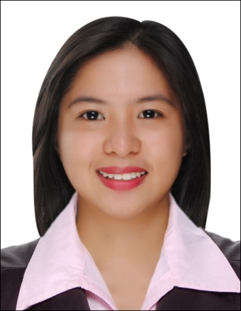
MARIA
MARIA.337246@2freemail.com

Banking and Finance – 3 years and 6 months experience

PROFESSIONAL EXPERIENCE

October 2011-April 2015

- Loan Support Staff Mount Makiling Rural Bank Inc. October 3, 2011-April 13, 2014
(Philippines)

- Loan Support Staff 2 Mount Makiling Rural Bank Inc. April 13, 2014 -April 15, 2015
(Philippines)

- Ticketing daily transaction such as Analysis of Loan, Official Receipt and Loan releases.
- Filing the duplicate copy of the ticket on their designated compilation
- Computation of Portfolio-At-Risk for monitoring of past due accounts in microfinance loan.
- Monitoring of the clients post-dated checks.
- Monitoring of the payments of regular loan clients
- Monitoring of the due Insurances.
- Preparing DM/CM (as payment for their loan true for those who are depositing in BDO and Advance Depositing on their savings account.)
- Assisting the clients when they have questions regarding their loans or other matters.
- Preparing Computation Slips for those have due on their loan or who wants to fully paid their accounts.
- Preparing reminder letters for those accounts who have due on that month.
- Releasing of the regular loan and salary loan.
- Preparing Loan agreement for every loan releases.
- Compilation of the release forms and other documents and preparing collateral in folder for the titles of the regular loan clients.
- Preparing checklist of collateral in folders for faster and more convenient checking of accounts.
- Checking of Collateral in folders whether they are complete or not and preparing tickets for new accounts for checking purposes.
- Batching of Loan due for the day.
- Preparing weekly, monthly, quarterly and year-end reports.

EDUCATION

June 2007 – April 2011
Bachelor of Science in Business Administration (BSBA-HRDM)
Major in Human Resource Development Management
La Consolacion College Tanauan – Philippines

PERSONAL INFORMATION

Age : 25
Status: Single
Nationality: Filipino

INFORMATION TECHNOLOGY

- Microsoft Office - Word, Excel, Powerpoint
- Micro-Banking System

SKILLS AND CAPABILITIES

- Good Communication Skills
- Document Control
- Computer Literate

TRAININGS AND SEMINARS

- Leadership Training – We Lead As We Serve
- Academic Seminar -- The Anatomy of an Entrepreneur
- Business Forum -- The Best of Times, The Worst of Times-- HR’s Challenges and Agenda in today’s Business Unusual
- 1st JMAP Convention-- Linking HR Effectiveness to People and Business Outcomes
- On-the-Job Training-- Human Resources Section
- Team Building
- Know your Money and Counterfeit Detection Seminar

