CURRICULUM VITAE

GULAM.2023536@2freemail.com 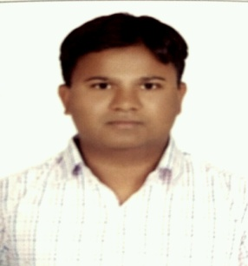

GULAM
Dubai, U.A.E.

Career Objective
To associate myself with an organization where there is an opportunity to share, contribute and upgrade my knowledge. My interest in this position stemmed from my long lasting ambition of working in such challenging position in a professional environment that will develop my skills and knowledge.

Strengths
- Creative, enthusiastic, honest, hardworking, well organized, able to build good relations with people, & well prepared for relocation as per the requirements.
- Strongly believe in teamwork. Always prepared to work in day/night shifts.
- Ability to work independently or as a part of team.
- Ability to understand, ability to develop and work on new projects.

Educational Qualification

- Graduate in Commerce from Osmania University.INDIA (2008-2010)
- Intermediate from Board of Intermediate Education (2001-2003)
- S.S.C from Board of Secondry Education (2000-2001)

Software Knowledge

- MS-Office & Windows95, 98, XP.
- Auto Cad 2014
- Basic Knowledge in M.E

Training Attended:

Personality Development & Mind Management By: Mr.A.H Hussein Rangwala from UK.
CRM (Customer Really Matters) By: Mr. Manish Adwani from Uk.

Working Experience:

- CASHIER In Dammam Saudi Arabia (May 28-2014 Aug5-2016).

Cashier Responsibilities:

- Handling cash trasactions with customers
- Scaning goods and collect payments
- Issue receipts, refunds, change or ticket
- Resolve customer complaints, guide them and provide relevant information
- Greet customers when entering or leaving establishments
- Maintain clean and tidy checkout areas
- Keep report of transactions
- Pleasantly deal with customers to ensure satisfaction
- Compute and record totals of transactions.

Talent Engagement and Development:

- Work in collaboration with Talent Management in retaining high performers and fostering an open and transparent work environment
- Provide support and guidance to team members
- Actively participate in performance evaluations and feedback sessions

PERSONAL PROFILE

Date of birth : 16th April 1982
Place of birth : Hyderabad
Marital status : Married.
Nationality : Indian
Religion : Islam

Place:

Date:

