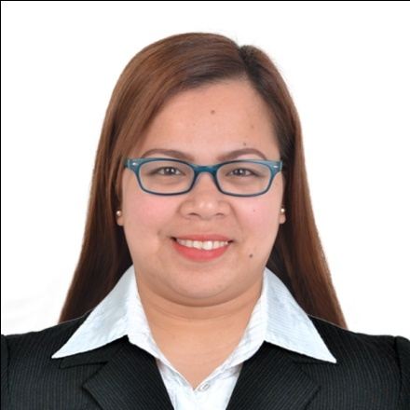

NORY
NORY.337265@2freemail.com

Career Objectives:
Always seeking innovative and challenging career in the professionally managed and dynamic organization, which provides the best opportunities for the development, and greater responsibilities to contribute towards organization.

Personal Information:
Age : 31
Gender : Female
Date of Birth : May 8, 1985
Place of Birth : Calamba, City
Civil Status : Married
Citizenship : Filipino
Height : 5’2”
Weight : 60 kls.
Religion : Roman Catholic
Dialect / Language : Tagalog / English

Educational Background:
Tertiary : BACHELOR OF SCIENCE IN SECONDARY EDUCATION
(2002-2006) Saint John Colleges
Chipeco Avenue, Calamba City
Licensure Examination for Teachers Passer

Secondary : CALAMBA BAYSIDE NATIONAL HIGH SCHOOL
(1998-2002) Palingon, Calamba City

Primary : JOSE RIZAL MEMORIAL SCHOOL
(1992-1998) J.P Rizal St., Calamba City

Special Skills:
Computer literate, Internet Explorer

Affiliation:
2002-2006 : Working Scholar Organization
Saint John Colleges (Member)

2004-2006 : Top Scholars of Laguna
By Gov. Ningning Lazaro (Member)

Work Experiences:
January 2012- December 2016 : Quality Assurance Staff
National General Insurance
Quality Assurance Department
SPI GLOBAL
Position Description:
- Responsible for the execution of all quality-related actions of the project, and ensuring that they are performed properly according to pre-defined processes and project requirements.

Duties and Responsibilities:
- Studies and analyzes project specifications and requirements.
- Performs quality inspection in accordance with project requirements and quality standards.
- Coordinates with the Lead Quality Inspector as to quality control points and other quality checking requirements.
- Informs the Lead Quality Inspector of any discrepancy or problem encountered while doing the assigned task.
- Asks for updates or changes in instructions (if any) during his/her absence in the office, prior to performing his/her assigned task.
- Uses the department’s reference materials and non-consumable supplies properly.
- Ensures that transactions and activities relating to actual performance are complete and accurate.
- Checks equipment and peripherals before using it to ensure smooth flow of work.
- Reports machine/network breakdown to Lead Quality Inspector or Shift Supervisor.
- Ensures that job priorities are always followed.
- Ensures that all procedures, instructions and processes in the department are documented and being followed in conformance with company’s quality system requirements.
- Ensures timely submission and completeness of reports required by the position.
- Participates in the continuous improvement activities of the company.
- Performs tasks relating to quality initiatives of the company.
- Ensures cleanliness and orderliness in the work area.
- Perform other duties as maybe assigned.

September 2008- January 2012 : Indexer/ Transact Analyst
National General Insurance
Production Department
SPI GLOBAL
Position Description:
- Responsible for analysis, encoding, verifying and modifying records according to the prescribed job standards and specifications and producing high quality database products through efficient and accurate data capturing.

Duties and Responsibilities:
- Analysis of source materials for proper data capturing.
- Updating of collateral records as specified in the project specifications.
- Encodes and verifies data in accordance with project schedules and Company’s productivity and accuracy standards.
- Attends orientation and listens to instructions being disseminated and ensures that these are well understood.
- Asks for updates or changes in instructions in case of absence for a short time.
- Adheres to the Transaction Analyst Work Instruction.
- Use Transaction Analysts’ reference materials (Project Specifications) and non consumable supplies.
- Ensures that all procedures, instructions and processes in the department are followed in conformance with the existing quality system requirements.
- Informs superiors of any discrepancies or problems encountered while doing the assigned task.
- Maintain the Company’s daily terminal requirement.
- Checks equipments and peripherals before using it to ensure smooth flow of work
- Maintains cleanliness and orderliness in the work area.
- Reports machine/network breakdown to LTA/Shift Supervisors
- Performs other duties as may be assigned.

June 2006-June 2008 : Teacher
Saint John Colleges
Position Description:
- Do records of the students.
- File all the documents of the students.
- Computerized all the documents.
- Do different kinds of form.
- Do evaluation of the students.
- Assist and give exam during enrollment.
- Type all the exams.

June 2006-June 2008 : Library Clerk
Saint John Colleges
Position Description:
- Better utilization of the Library by both student and faculty.
- Conduct orientation in the library for incoming students
- Inform teachers of services the library provides.
- Training of library students aids.
- Organize and evaluate with faculty upgrade of library books and references.
- Promote the use or library materials via bulletin boards, displays, etc. to students and faculty.
- Assist in the formation of library policies.
- Original cataloguing of all library materials/ computer generated.
- Other duties assigned.

June 2002-March 2006 : Student Assistant
Library & Guidance Office
Saint John Colleges

I hereby swear that the above information is true and correct to the best of my knowledge and belief. I also authorized your good office for the confirmation of the above information.

