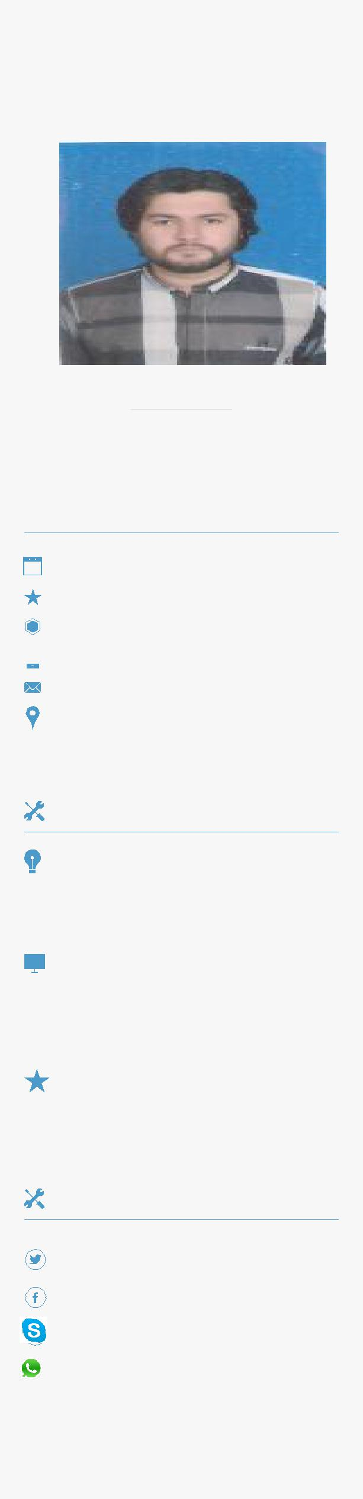

NAVEED

ELECTRICAL ENGINEER

PERSONAL DETAILS

 | M. Status | Single ☺
 | Nationality | Pakistani
 | Email | Naveed.337283@2freemail.com
 | SKILLS

OBJECTIVE

Seeking a job in an organization to utilize my knowledge and potential to gain a better experience where I can contribute in its growth while enhancing my professional abilities.

EDUCATION

 | B.sc Electrical | UET LAHORE Via | CGPA
 | Engineering (Power) | NFC Institute of Engineering & | 2.93/4.00
 | 2011 – 2015 | Fertilizer Research, Faisalabad
 | F.SC (Pre-engg) | BISE LAHORE Via | 832/1100
2009-2011 |  | Govt.Islamia College Civil
 |  | Lines Lahore.
 | Matriculation | FEDERAL BOARD Via | 860/1050
 | Science | Garrison Academy For Boys
2007-2009
 |  | Lahore Cantt.
 | PROJECTS
 | Final Year Project | Semester Projects
Variable Frequency Drive For |  | ▪  Room thermometer using Arduino board
3 Phase 5 HP Induction Motor. |  | ▪  Digital clock

- Speed Control of DC Motor

- Digital voltmeter using PIC microcontroller

- Complete house wiring

Knowledge | Industrial System
 | Control Systems
 | Power generation,
 | Transmission &
 | Distribution
Computer | Power Electronics
 | Proteus ISIS & ARES
 | Electronic Workbench
 | Verilog and Xilinx ISE
 | MATLAB
 | C++
Languages | MS OFFICE
 | Urdu
 | English
 | Punjabi

EXPERIENCE
Internship

Jun 2014 - July 2014

Practical

2014-2015

Experience
2016

N.T.D.C LAHORE.

• One year practical Labs at WAPDA ENGINEERING ACADEMY FAISALABAD.

• Training experience in power house of
prosperity weaving mill.NAGINA GROUP
ORIENT ENERGY SYSTEM.
Working as an assistant shift incharge

- CAN OPERATE OR CONTROL GAS ,HFO AND DIESEL GENSETS.

- CAN TROUBLESHOOT ELECTRICAL FAULTS

HOBBIES

Learning New Software - Reading - Social Networking – Music

REFERNECES

Available on Demand

