Vanessa
Vanessa.2023800@2freemail.com
UriarteSubd., La Carlota City

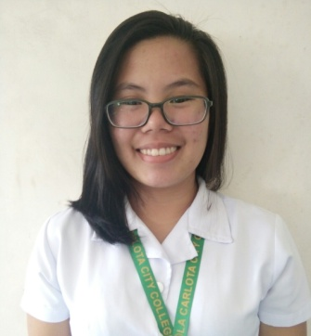

OBJECTIVE: I want to succeed in a stimulating and challenging environment, building the success of the company while I experience advancement opportunities.

STRENGTH:
• Hard working and dedicated.
• Creative and Resourceful.
• Ability to deal and interact with different kind of people.
• Eager to learn and contribute the growth of an organization.
• Good team player, keep motivated coworkers to achieve given targets.

Working Experience

2009-2016 , La Carlota City, Negros Island
Region

Educational Background

June 2015-January 2017 La Carlota City College, Lacarlota City, Negros Island Region
June 2013-March 2015 Maranatha Baptist Bible College Villamonte, Bacolod City, Negros Island Region
June 2008-March 2012 Doña Hortencia Salas Benedicto National Highschool, La Carlota City, Negros Island Region
June 2003-March 2008 La Carlota South Elementary School, La Carlota City

Skills

Management skills
Communication skills
Problem-solving skills
Cooking skills
Designing skills

Personal Background

Date of Birth: August 04,1995
Place of Birth: Bacolod City
Citizenship: Filipino
Civil Status: Single
Gender: Female
Religion: Baptist

