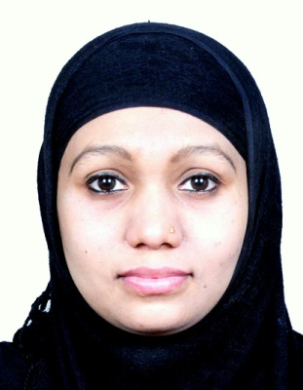
AFREEN
AFREEN.337324@2freemail.com
LOOKING FOR JOB IN IT
SOFTWARE TESTING ENGINEER
Industry Preference: IT
Location Preference: ABU DHABI
55 4135 786
Key Skills
Software Testing
Hardworking
Self motivated
Fast Decision
Honest
Persistence
Flexibility
Adaptibility
Positive Attitude

 | - Profile Summary
- Currently has experience of working as part of a close knit team performing testing procedures on software applications and ensuring that all errors are identified and corrected before release to the clients.
- Having excellent problem solving and analytical skills and experience of throughout the life cycle of a project from specifications reviews through to user acceptance.
- Excellent communication and interpersonal skills and ability to liaise with key customer contracts and vendors to resolve software issues.
- Presently looking for a suitable software tester position with an ambitious company.
- A keen communicator with honed interpersonal, analytical and problem solving skills

Career Timeline
DIPLOMA Training in C programing from Atlanta
zz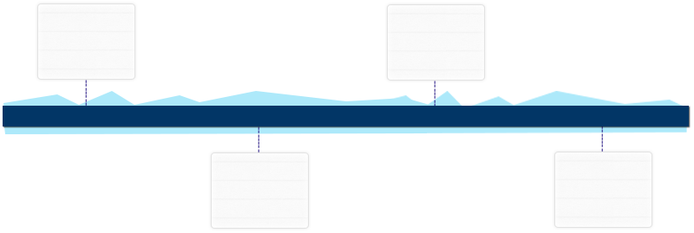

Worked as a Software Tester in M/s. Alivetech Software Solutions Nagpur from August 2014 to February 2015

Completed Swarm Robotics Workshop in Technical Event

JAVA Training from Government Polytechnic

March’12
Aug’14-Febr’15
May’12-July’12
Since JUN’11
zzz  Education | - B.E. in Electronics & Telecommunication from Rajiv Gandhi College RTM University with 61.89% [2013]  - Diploma in Electronics & Telecommunication from Anjuman Polytechnic MSBTE with 80.12% [2010]  - Secondary School Certificate from Orange City High School Nagpur with 76% [2005]
Work Experience  Since  Aug’14-Feb | Worked as a Software Tester in Alivetech Software Solutions Nagpur and have worked on live project in company.  Highlights:  - Knowledge of user documentation, training documents & user acceptance plans.  - Knowledge of functional, reliability and performance testing.  - Experience of working in pressured environment to strict deadlines.  - Extensive knowledge of open GI applications & MS Office Suit.  - Ability to learn new software quickly.  - A thorough understanding of the software development process.  - Comprehensive understand of languages such as C, C++ and java.  - Extensive knowledge of full software testing life-cycle.  - LANGUAGES KNOWN: C, C++, JAVA, SQL Server 2008 Basics.  - TESTING TOOLS: Selenium IDE, QTP [HP], Redmine, JMeter.  Key Result Areas:  - Testing software to identify and resolve problems from an end- user perspective.  - In charge of testing developed software against specified requirements.  - Accurately monitoring and recording results in test documentation.  - Liaising with developers to swiftly resolve problems.  - Analyzing, writing reports & communicating results to colleagues and managers.  - Monitoring the testing process, identifying and logging test failures.  - Performance peer reviews and estimates.  - Involved in performance Testing, Scalability / Stress and load testing.  - Testing full product suits, identifying problems & resolving them with the development team.  - Liaising closely with the software development team to understand what a software program is meant to do. Then developing examining all aspects of the program from a clients or end-users perspective and finally finding and eliminating any problems if so ever.  - Worked as a trainee Software Engineer and completed 6 month Internship Training in AliveTech Services.  - Workshop training on Swarm Robotics.  - Core and Advance Java course training with ‘A+’ Grade.
Training

IT Skills | - Microsoft Office Suite Applications-Word, Excel, Access, Visio, PowerPoint & Internet  - Programing language C and Advance and Core JAVA.

