 | Curriculum Vitae
 | Personal Information
Name  Date of Birth  Nationality  Email |  |  | RASHEED  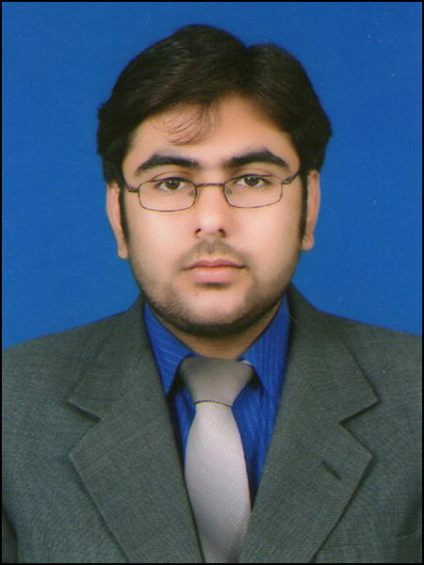  23-11-1987  Pakistani  RASHEED.337327@2freemail.com
 | Objective
 | To enter into a dynamic professional career where I could work in a competitive environment and respond to emerging challenges by making optimum use of my expertise in order to harness science and technology for the comfort and betterment of humanity.
How can I contribute for your Esteemed Organization? |  |  | • I can prioritize all programs and activities.  • I can independently take initiative for achievement of targets  • I can present and demonstrate on my performance indicators.  • I have interpersonal skills for team coordination and work.  • I can document the organization’s work as and when assigned to me.
Organizational skills and Flexibility |  |  | • Strong multi-tasking and organizational skills.  • Ability to work long hours in stressful, often insecure environments.  • Ability to maintain an esprit de corps with a team.  • Proven team-building and team leadership skills.
 | Qualification
Course and Institution |  |  |  | Division/Grade | Year
Pharm-D (gomal university dera Ismial khan) |  |  |  | 1st Div | 2006-2011
HSSc (Pre-Medical) Board of Intermediate and Secondary Education dera ghazi khan |  |  |  | A-Grade | 2006
SSc (Science) federal board Islamabad |  |  |  | A- Grade | 2003
 | Tools and Technologies
Desktop Publishing Tools
MS Word, MS Power Point, MS Excel.
Windows XP, 98, 2000, 2007. , Vista

Field Experience
- Currently working as second pharmacist in MMC pharmacy (alnoor-medclinic group)ajman branch
- Worked as second pharmacist in Al-Madina pharmacy 24 hours ajman UAE for 2 years
- Worked as trainee in scientific pharmacist sohar oman
- worked as pharmacist in RMI Peshawar iso certified, for over 2 year
- Worked and trained compounding and retail dispensing pharmacist in AFIC-MH Rawalpindi pharmacy.
- Wards orientations, drug information, clinical information, event management Sops formation

Skills
- Insurances medicines dispensing and approvals used in uae
- Inventory control for pharmacy
- Setting definite par levels for ordering and re-ordering of medicines
- Patient counseling, expiry checking, Iso standardization sops.
- Hospital pharmacy experience, drug and poison information center experience, communication with health care team and patients regarding medicines
- Iv admixtures , extemporaneous preparation according to the need of patients specific case
Extracurricular Activities
President Study Aid Foundation For Excellence Pakistan(SAFE) HEC recognized since 2006 in gomal university
Member GOMALIAN STUDENT COUNSEL for 2years
References
Will be furnished on demand

