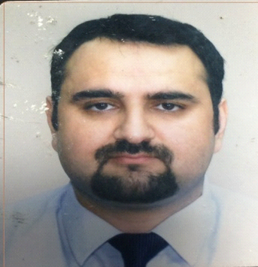
IMRAN

IMRAN.337333@2freemail.com

Career Objective
To join a well- known Organization that believe in building Career by smart and intelligent application of my technical and management skills .Experienced hotel management professional with a proven record of managing hotel operations and staff. Well versed in custodial staff management, client complains handling and budgetary monitoring.

Core Competencies
- Banquet arrangements Housekeeping
- Employee Training Cash handling
- Customer Service Event/Catering Management

Employment &Experience

The Brompton Hotel London***Accommodation / Service Manager Jan 2013-Nov 2015
- Assume authority for the hotel in the absence of the General Manager and serve as for all operations within the hotel. Ensure that every department head is aware of operational goals and hence is made aware of the necessary tools.
- Planning the accommodation and catering along with other hotel service.
- Promoting and marketing the business.

Belgravia Hotel London**** Front Office Manager Jul 2012-Dec 2013
- Deliver excellent customer service, at all times, ensuring guests ' comfort and safety.
- Deal with all enquires of front office in a professional and courteous manner, in person, on the telephone or via e-mail.
- Assist in keeping the Front Office clean and tidy, at all times and deal with customer complaints in a professional manner.
Pearl continental Hotel Peshawar***** Guest service Supervisor Jan2012-Feb 2012
- Duties typically include interviewing, hiring, training, scheduling and managing employees, as well as overseeing inventory, including food and beverages, supplies and other restaurant equipment.
- Responsible for resolving customer complaints regarding food quality and service and making sure the business complies with health and food safety regulations.
- Performing administrative tasks such as managing payroll and writing budgets.

The Brompton Hotel London*** Duty Manager Jan 2010 - Nov 2011
- Deliver excellent customer service, at all times, ensuring guests’ comfort and safety
- Deal with all enquires in a professional and courteous manner, in person, on the telephone or via e-mail
- Keep up to date with current promotions and hotel pricing
Cost Cutter Lime House London Sales Manager March 2016 to Nov 2016
- Managing and motivating a team to increase sales and ensure efficiency; managing stock levels and making key decisions about stock control.
- Analysing sales figures and forecasting future sales. Analysing and interpreting trends to facilitate planning .using information technology to record sales figures, for data analysis and forward planning.
- Dealing with staffing issues such as interviewing potential staff, conducting appraisals and performance reviews.

Internship & voluntary work
2007 - AKRSP Pakistan (Ngo) 2008 - Biyar Local Support Organization chitral (Ngo)

EDUCATION & QULAIFICATIONS
Diploma (Hotel Management)
London school of Science &Technology (UK) 2011

Diploma in Business Management
Waltham Forest College London (UK) 2013

Post Graduate certificate in Strategic Management & Leadership
Waltham Forest College (UK) 2014

Languages:
English, Urdu, Pashto, Hindi. Farsi, Kowari

Technical Skills:
Micros, PMS Opera, HMS, Callista Software, MsOffice

References
Available on request..................

