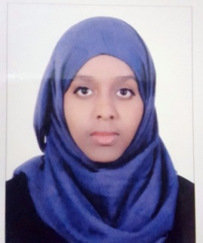
Hana

Hana.337374@2freemail.com
Profile
Positive, organized, confident and great team player and good in performing routine tests in medical diagnostic testing and microbiological analysis . skilled in the hematology examination .Tolerant, Learns quickly and doesn’t give up easily.self-starter able to work under minimal supervision . I have been trained in Mafraq hospitalfrom (05.10.2015 ) to (04.04.2016) . I have completed the ASCP Board of Certification International Medical Laboratory Scientist examination.

Education and Qualification
Graduate
2014 – 2015 University of Sharjah Majoring in Medical Lab Sciences
With GPA 2.97

Core strengths
- Urinalysis testing
- Phlebotomy process
- Workplace safety regulation
- Critical thinking and analysis
- Microbiology and parasitological testing
- Histology examination
- Blood bank examination
- Research experience ( in colon cancer markers )

Skills
- Computer skills: MS office: Word, PowerPoint, and Excel. Moviemaker and Internet Explorer
- First aid

Worked with
- Cobas 6000.
- Vitec ( sensitivity testing of bacteria )
- Cryofuge centrifuge jouan (blood unit centrifuge )
- ELISA tests
And many more …….
Interested in working in
- Microbiology lab
- Hematologylab
- Blood-bank
- Histology lab

