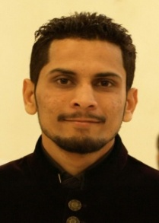
Muhammad
Muhammad.337385@2freemail.com

CAREER OBJECTIVE:

A competent pharmacist having sound knowledge of clinical, community and retail pharmacy, dispensing, patient counseling and healthcare services. Efficient in situation handling in the hour of need.

INTERNSHIPS:

- One month as a community pharmacist at Clinix+ Thokar Niaz Baig branch.

TRAININGS AND WORKSHOPS:

- Two days training workshop on “Understanding leadership‘s dynamic “organized by “Superior University” in 2012.
- Brand activation campaign of “Daily NaiBaat” in 2012.
- Participate in the management and documentation for the visit of “Pharmacy Council of Pakistan” for the registration and accreditation of “Department of Pharmaceutical Sciences Superior University” in 2015.
- Participate as an “Events Organizer” in “Superior Pharmaceutical Society” of “Superior University” from 2011-2015.

RESEARCH WORK:

Review article:
- Trend in abuse and misuse of drugs
- Prevalence of anxiety in different areas of Punjab.

ACADEMIC QUALIFICATION:

Matriculation BISE Lahore 2008
Intermediate BISE Lahore 2010
Pharm D Superior University Lahore 2011-16
HOBBIES:

- Reading clinical books
- Badminton
- Internet Surfing

