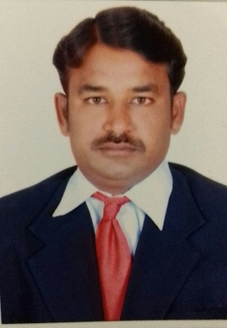
CURRICULUM VITAE

GANESH
GANESH.337407@2freemail.com

OBJECTIVE:

Seeking a position as an Accountant where extensive experience will be further developed and utilized.

PERSONAL SKILLS:

- Detail-oriented, efficient and organized professional with extensive experience in accounting systems.
- Possess strong analytical and problem solving skills, with the ability to make well thought out decisions.
- Excellent written and verbal communication skills.
- Highly trustworthy, discreet and ethical.
- Resourceful in the completion of projects, effective at multi-tasking

EDUCATIONAL QUALIFICATION:

- Master's Degree in Business Administration (MBA) completed in 2014 from Osmania University, Hyderabad in specializing in Marketing & Finance.

- Bachelor of Science (Mathematical Science) completed in 2008 from Sai Triveni Degree College affiliated to Osmania University.

- Intermediate completed in 2004 from Sri Venkateshwara Junior college affiliated to Board of Intermediate Education, Telangana.

- Secondary school of certificate completed in 2002 from Vignan High school, Arvapally, Nalgonda, Telangana.

PROFESSIONAL EXPERIENCE:

KOLAN ENG. CONSTRUCTION PVT. LTD. (Assistant Accountant & Purchasing Officer)

(SEP 2014 -MAY 2016)

- Managed accounts payable, accounts receivable, and payroll departments.

- Generated budgets and forecasts on a quarterly basis and presented to the management team.

- Reported on variances in quarterly costing reports.

- Managed payroll function for 140 employees.

- Monitored and recorded company expenses.

- Prepared annual company accounts and reports.

- Successfully maintained book keeping about store room stock positions.

UPKAR INFRA PROJECT PVT. LTD. (Assistant Accountant cum Storekeeper)

(SEP 2008 -AUG 2012)

- Maintained strong relationship with key contacts in existing accounts and present accounts.

- Performed accounts payable functions for construction expenses.

- Managed vendor accounts, generating weekly on demand cheques.

- Managed financial departments with responsibility for Budgets, Forecasting, Payroll, Accounts Payable and Receivable.

- Created budgets and forecasts for the management group. Purchased the vehicle and Machine Spare parts as require.

- Ensured compliance with accounting deadlines.

- Prepared company accounts and tax returns for audit.

- Coordinated monthly payroll functions for 200+ employees.

- Liaised good relation with bankers, insurers and solicitors regarding financial transactions.

Computer/Software Exposure:

- MS-Office, Computerized Financial Accounting (TALLY)

- Operating Systems : Ms Dos , Windows 98,2000,XP &Windows7,8&10

PERSONAL INFORMATION:

Date of birth : 18 July 1987

Linguistic Proficiency : English, Hindi and Telugu

Marital Status : Single

Sex : Male

Visa Status : Visit

Hobbies : Playing Cricket, Reading Books, Cooking.

Declaration:

I declare that the particulars furnished above are true to the best of knowledge and belief.

