Curriculum Vitae
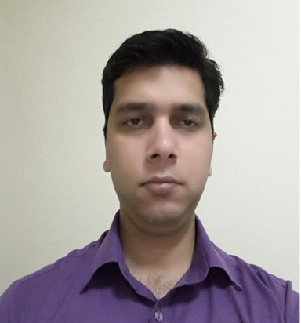
SHAHBAZ
SHAHBAZ.337425@2freemail.com

CAREER OBJECTIVE:

To grow as a professional and learn new expertise in the field of management which will be fruitful in solving practical business problems and help the organization and me to soar new heights.

Area Of Expertise:

- Marketing
- Sales & Business Development
- Team Handling
- New Client Acquisition
- Sales Promotion
- Customer Service
PROFESSIONAL WORK EXPERIENCE:

1) Working in Jumbo Electronics Company Ltd LLC as
a Sales Advisor.
(Currently Working as Acting Section In charge)
Joined on May 7th, 2014 - present date. ( 2 Years 9 Month )

OVERVIEW OF CURRENT JOB: (Acting Section IN Charge)

- Supporting the Store Manager and Team in all aspects of the work.
- Working as a acting Section In Charge.
- Assisting with all the documentation of store.
- Handling the store in absence of store Manager.
- Achieving the Targets on individual basis as well as a team.
- Merchandising and implementing new layouts on regular basis.
- Keeping track of competitor’s lineup and promotion on regular basis.
- Keeping track on the fast moving SKU stock statement and arrangement
- Providing the Team with proper knowledge of new products and line up in the category.
2) Worked as a Business Development Executive in (IPITM)
Indian Pacific Institute of Technology and Management.
Joined on 9th of October, 2012. (1 year 1 month).

OVERVIEW OF JOB:

- Generating Leads and fixing appointments for through cold calling.
- Organizing Marketing Campaigns for Promotion of IPITM Educational Courses.
- Organizing presentations and seminars in office to different group of prospets.
- Handling Customer Queries & Providing adequate solution.
- Building relationships with clients and providing them best service and experience.
- Achieve monthly Targets.
- Providing service to Existing Customers.

Summer Internship project:
Company Name: - SMC Global Securities,
Duration: - 2 months from 26 April-18 June.
Project topic: - Analysis of risk profile of existing clients in SMC global securities

ACADEMIC QUALIFICATIONS:
- I.C.S.E completion in the year 2006 from ST Thomas Boys School, Kolkata.
- I.S.C completion with in the year 2008 from ST Thomas Boys School, Kolkata.
- B.COM (Honours in Accountancy) completion in the year 2011 from Calcutta University.
- PGDM/MBA completion in the year 2013 from Galgotias Business School.
- Successfully qualified and completed Toyota sales education foundation programme.

COMPUTER PROFICIENCY:
Professional hand on Microsoft office.
Oracle: Fundamentals of Oracle JD 9.1, Oracle POS.
CURRICULAR ACTIVITIES:

- Done job in expo mart as freelancer on the post of ( assistant Floor manager).
- Managed collage fest event as an event coordinator.
- Worked in the Formula 1 event of Buddha circuit in greater noida as a supervisor.

AWARDS AND ACHIVEMENTS:

- Was a part of work shop on merger acquisition conducted by professor of German University.
- Nominated by college and successfully completed marketing symposium organized by collage.
- Attended seminar in human resource organized by FICCI.
- Inter school cricket winning team member for 2 years.
- Inter school football winning team member for 1 year .
- HOBBIES: Listening to Music, Exploring new things, Travelling.

PERSONAL DETAILS:

- Gender : Male.
- Languages Known : English, Hindi, Urdu & Bengali.
- Date of Birth : 19th April , 1989
- Marital Status : Single.
- Nationality : Indian.

Declaration
I solemnly declare that above information is true and correct to the best of my knowledge

