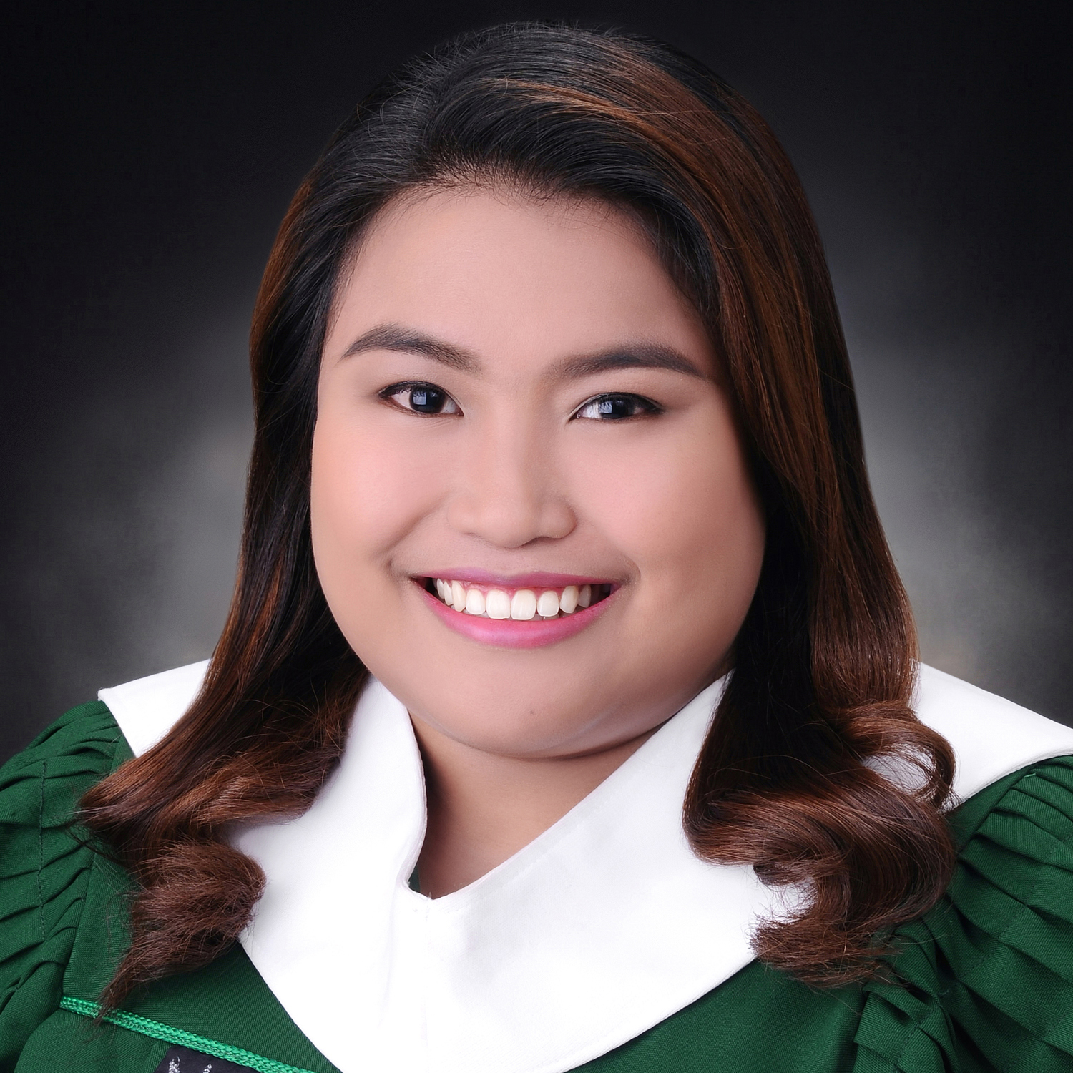
BEVERLY
BEVERLY.337440@2freemail.com

OBJECTIVE
To be able to land in a job that is in line with my course that can help me be better in my craft and mold me into being the career person that I should be.

EDUCATIONAL BACKGROUND

TERTIARY
Far Eastern University
Bachelor of Arts in Communication
Sampaloc, Manila
JUNE 2012-2016

University of Santo Tomas
Bachelor of Science in Civil Engineering
Espana, Manila
JUNE 2011-2012

SECONDARY
Pateros Catholic School
High School
B. Morcilla St., Pateros, Metro Manila
JUNE 2008-2011

SUMMARY OF SKILLS

- Well-versed not only in MS Office but also in Adobe Photoshop and Adobe Premiere Pro.
- Good communication skills.
- Web Content Writing
- Knowledge in Advertising, Journalism, and Photography.
- Knowledge in Events Management and Public Relations.
- Can work under pressure.
- Has keen eye for details.

EXPERIENCES

Junior Web Content Writer – Growth Rocket Consultancy Inc.
August 2016 - Present

Intern – This Side Up Manila
April 2015 – June 2015

