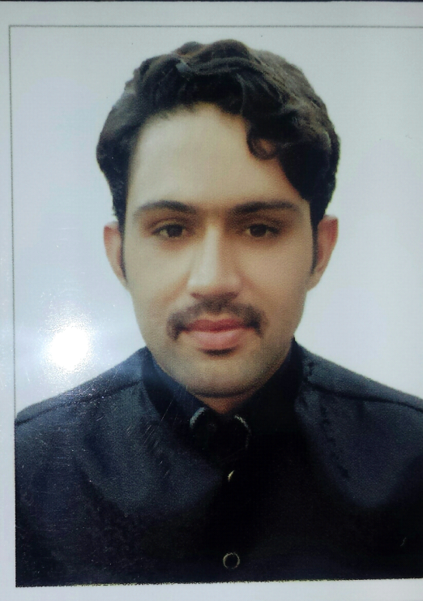

OBJECTIVE:

I am looking for a challenging position, preferably within the Finance OR Marketing sector, where I can enhance my knowledge and contribute my part. I have professional aspirations and with the proper training and guidance can be the best. I aim to achieve excellence in Accountant & Marketing and stand among the very best while working with a dynamic organisation. I believe in working smart rather in working hard.
Subject: (Looking Job with Marketing & Finance Sectors)
PERSONAL DETAILS:
Visa Status: Long Term Visit visa (90 days)
Present address: Al Nasserya Sharjah
Nationality Pakistani
Religion: Muslim, Sunni

PROFESSIONAL QUALIFICATIONS :
A) MBA (Marketing & Finance) 2015 National college of Business Admn &
Economics Lahore Pakistan.
The core modules covered in MBA were:
- Principal of Marketing Management.
- Project Management.
- Organizational Behaviour.
- Retail Management.
- Service Management.
- Sales Management.
- Accounting.
- Economics
- Statistics.
- Sociology.
- Business Research Methodology
- Revenue Management.

2) BBA (Marketing) 2011 Qurtaba University Peshawar Pakistan.

3) Fsc (Engineering) 2009 Jinnah College Swabi Pakistan.

4) Matric (Science) 2007 Jinnah School Swabi Pakistan.
PROFESSIONAL EXPERIENCE:

A) Marketing&Account Executive July 2013 june 2016 Ramiz International.
As Marketing Officer my responsibilities were:
What experience and training do you have in bringing advertising campaigns to the public?
- Market Strategy(Price,Place,Prmotion,Packaging).
- Packaging
- Content Marketing
- Customer Focus
- Swot(Strength,weekness,opportunity,threats).
B) Accounts Financial Report
- Oversee all accounting functions, such as accounts payable and accounts receivable.
- Maintain and monitor financial data related to investments.
- Establish internal accounting policies and procedures.
- Create financial reports and statements.
- Ensure compliance with tax requirements.
- Manage a team that may include accountants and assistants.
LANGUAGE SKILLS:
- English (fluent),
- Urdu/ Hindi (fluent),
- Punjabi (fluent),
- Pashto (fluent)
COMPUTER SKILLS:
- Proven proficiency in quick book pro (peachtree).
- I possess a very good aptitude for computer software and proven proficiency in use of Windows XP pro, Windows 7, Microsoft Office applications, including MS Excel, MS Access, MS Word, and MS PowerPoint. Internet Surfing and emailing.
TRAINING COURSES:
- 6 months Internship in Meezan Bank Limited.
ABOUT ME:

I have a close and cordial relationship with my family and friends. People have always looked towards me as trusted companion who has strict principles and rules and have cited my example, for my integrity, honesty, hard work and a smiling attitude. I have tried to live up to my parents’ expectations and to comfort whoso ever needed me.

References : Available on demand

