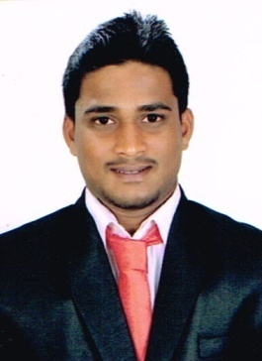
RESUME
JAMES

EMAIL: JAMES.337454@2freemail.com

CAREER OBJECTIVES:
To provide best services to an organization that gives an opportunity to utilize my knowledge and skills and to be a part of organizational excellence.
WORK EXPERIENCE:
Work experience in India (May 2014 – December 2016) Organization : H.L. Rao & Associates Role : Accountant/Auditor (May 2015 – December 2016) Responsibilities:
- Maintaining day to day Accounts.
- Independently handling accounts of Professional and Proprietary Concerns, Partnership Firms, Companies as well as Firms and Trusts.
- Preparation of Financial Statements viz. Audit reports, Profit & Loss account, Balance sheet, Income & Expenditure, Receipt & Payment account, etc.
- Valuation and Preparation of Closing Stock statements, Reconciliation Statements, Tax computation viz. Income tax, Sales tax , Service tax , Vat, TDS, etc.

Organization : Big Bags International Pvt. Ltd (May 2014 – April 2015)
Role : Human Resource Executive
Responsibilities :
- Recruitment Process.Campaigned in various places for hiring manpower requirement. Providing punching numbers to employees & updating it.
- Check list of company vehicles & updating it, Checking due date of insurance, emission test of company vehicles & updating it.
- Late coming & early going report of employees, OT calculation, Transportation & Canteen costing, Conducting various cultural programs for employees.

ACADAMICS:

Educational Qualification | Institution | Marks  (%) | Year of Passing
B.com | St Aloysius College Mangalore  (Autonomous) | 60.10 | 2014
PUC | St Raymonds Pre-University  College, Mangalore | 77 | 2011
SSLC | St Rosa Mystica High School,  Mangalore | 64.16 | 2009

PROJECT DETAILS:
- Did project work on “Loans and advances of syndicate bank, Mangalore. (January- March 2014)”.

COMPUTER SKILLS:
Operating system, Microsoft Word, Excel, Outlook, Power Point, (ERP), Tally (ERP 9),
Busy, Peachtree.

EXTRA CURRICULAR ACTIVITIES:
- Participated in collage competition and won first price.
- Had been part of the planning committee for the ACME-College fest.

AWARDS:
- Represented the college team in cricket and won various awards in it.
- Represented the college team in football and won various awards in it.

PERSONAL DETAILS:
Date of Birth: 11th July 1993
Linguistic Abilities: English, Hindi, Kannada, Konkani

Strengths:
- Optimistic and a quick learner
- Strong communication and interpersonal skills
- Self-motivated, dedicated and meticulous approach to work

DECLARATION:
I hereby declare that the above information is true to the best of my knowledge.
Date: 22-01-2017
Place: Abu Dhabi

