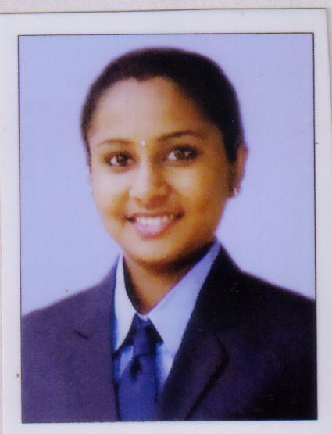

Dhanya
Dhanya.337500@2freemail.com

Objective
To work with an organization where I can utilise my skills and knowledge effectively thereby contributing to achieve the goals of the organisation and my professional development.

Educational Qualifications

MBA(Specialisation in HR and Finance) from Bangalore University.
B.Com from Dr. Harisingh Gour University, Sagar Madhya Pradesh.
H.S.C. from CBSE Board, St.Mary’s Senior Secondary School, Ranni Kerala.
S.S.C fromCBSE Board, St. Mary’s Senior Secondary School, Ranni Kerala.

Computer Proficiency

MS-Excel, MS-Word, MS-PowerPoint, Tally ERP-9.0, MS Outlook

Project Work

- Title: Study on Lack of Promotional strategy and its impact on Customer Satisfaction.
Location:Milma Dairy ,Pathanamthitta, Kerala.
Duration:20th July to 19th August 2015.
- Title: Study on issues related to Employee-Employer relationship.
Location:Travancore Titanium ProductsLimited, Trivandrum, Kerala
Duration: 29th March to 12th May 2016.

Strengths

- Interest in learning new things and self-motivation.
- Adaptive and good team player.
- Quick learner and organized.

Personal Dossier

Date of Birth : 02/03/1994
Marital Status : Single
Gender : Female
Nationality : Indian
Area of Interests : Music, Dance, Internet browsing, Nail art.
Languages Known : English, Hindi, Malayalam and Tamil

Declaration

I hereby declare that the above furnished details are fully true to the best of my knowledge and belief.

Place:
Date:

