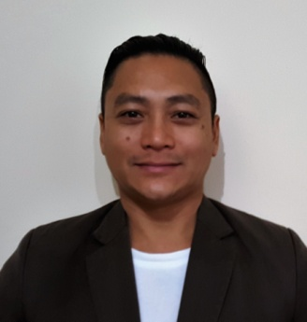
JOHN
JOHN.337505@2freemail.com

Summary
Representative salesman in retail sector, throughout career acquire solid understanding of customer expectations, effective sales methods, in-store experience and retail market trends. High energy level, initiative and confidence achieve outstanding sales results.

Core Competencies Include
- Good/Effective communication skills.
- Persuasive
- Customer service orientation – stress tolerance, patience and integrity
Objective
Seeking a dynamic environment to employ sales skills for growth of organization.
Professional Experience

Nike Stadium Rockwell Philippines
Retail Sales Associate/Representative June 1998-2003

Key Performance:
- Assisted and encouraged customers in selecting and purchasing required products in a retail environment.
- Addressed customer’s needs – Advised and helped locate appropriate merchandise.
- Described products feature/benefits and demonstrated usage/operation of products.
- Answered/addressed customers question – provide information concerning specifications, warranties, financing available, maintenance of merchandise and delivery options.
- Arranged display of merchandise in retail store.
- Organized goods exchanges – Repair or alteration of merchandise.
- Coordinated stock inventory and requisition of new stock.
CROCS Megamall Philippines
Retail Sales Clerk 2003-2008
- Stock shelves, counters or tables with merchandise.
- Set up advertising displays or arrange merchandise on counters or tables to promote sales.
- Stamp, mark or tag prices on merchandise.
- Obtain merchandise requested by customer or receive merchandise selected by customer.
- Answer customer questions concerning location, price and use of merchandise.
- Total price and tax on merchandise purchase by customer to determine bill.
- Accept payment and make change. Wrap or bag merchandise for customers.
- Remove and record amount of cash in register at end of shift.
- Calculate sale discount to determine price.
- Keep record of sales, prepare inventory of stock and order merchandise.
- Keep the showroom clean and orderly.

Samsung Electronics SM Annex Philippines
Store Supervisor
2008-2016
- Manage retail staff, among which includes people working on the floor, and the cashiers
- Make sure pricing is correct
- Evaluate self-on-the-job performance, as well as other staff
- Utilize computers to record sales figures, for data analysis and forward planning
- Organize and distribute staff schedules
- Help, drive, motivate, and encourage retail sales staff to achieve sales targets
- Handle customer complaints, issues and questions

Education

College
Bachelor of Science in Nursing
St. Jude College of Nursing (1991-1992) (1993-1996)
High School
Espiritu Santo Parochial School 1987-1991
Elementary
Espiritu Santo Parochial School 1981-1987

Personal Data

Birth Date : December 19, 1973
Birth Place : Manila
Civil Status : Married
Nationality : Filipino
Language / Dialect : English, Filipino
Visa : Tourist

