Farhana
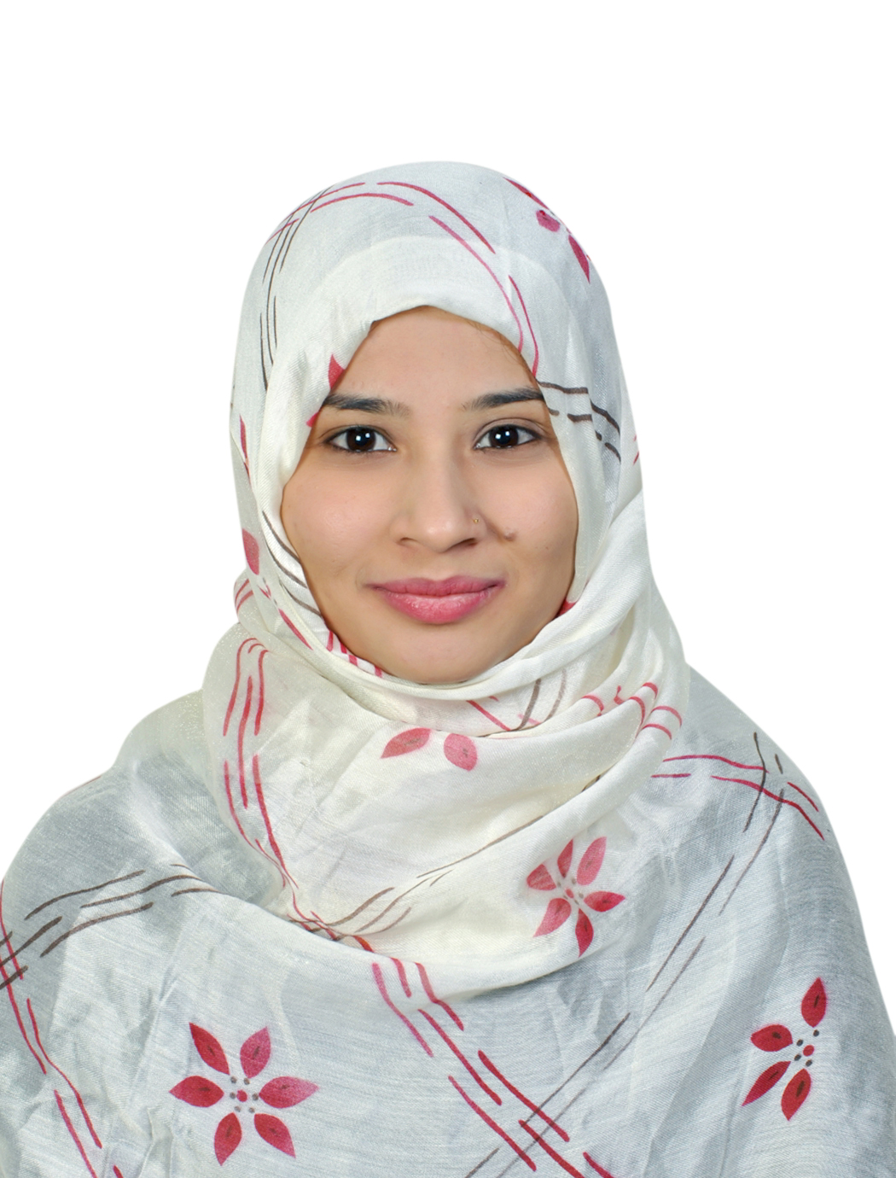
Farhana.337521@2freemail.com

Microsoft Certification Id:
- Microsoft Certified in Web Application Development with Microsoft .Net framework 4.0(Exam 70-515).

Carrier Objective:

- To accept the challenges and look for rewarding job opportunity, that can provide me a good working environment and help me to emerging as competitive professional that will exploits my inner talent.

- With a positive attitude, able to handle assignments under high pressure and consistently meet deadlines. Possess excellent team participation, communication and customer interaction skills.

- Goal-oriented, multi-tasking professional with wide range of skill sets as well as strengths in technology, troubleshooting, problem analysis and resolution.

- To be associated with a progressive organization that gives me ample challenges to help me apply my knowledge and skills in Programming and to work in a team that works dynamically towards the growth of the Organization

From September 2013 to September 2016 worked with SYNC Technologies as Senior.Net Developer, Andheri.

Synopsis:
- Platform:ASP.NET
- Version :4.0
- Backend: SQL Server 2012
- Build web site for Recruitment Product.
- Main Product is Applicant Tracking System (ATS).
- Working to implement recruitment software.
- Working to provide support to software and implement new functionality.

ACADEMIC QUALIFICATIONS:

Qualification | University/Board | Year of passing | % obtained
BE(Computer) | NMU | 2012-13 | 66.06%
TE(Computer) | NMU | 2011-12 | 57.00%
SE(Computer) | NMU | 2010-11 | 58.73%
FE(Computer) | NMU | 2009-10 | 66.00%
HSC | NASIK | 2008-09 | 67.00%
SSC | NASIK | 2006-07 | 78.15%

PROFESSIONAL QUALIFICATION:

Microsoft Exam Id: 11189336
- Microsoft Certified in Web Application Development with Microsoft .Net framework 4.0(Exam 70-515).
- C#.net
- Asp.net
- C, C++, Oracle10g, SQL, Java (entry level).
PROJECT:
- Final year project: ‘Authentication scheme for session password using text and color’.
This project aims to develop two authentication techniques (pair based authentication schemes and hybrid textual based) for engendering the session passwords for PDA which Will be implementing in Java. These techniques are resistant to brute force attack, dictionary attack and shoulder surfing.
- Third year project: ‘Secure Communication using Cryptography’
As cryptography is simplest way to convert given text into unreadable format (Cipher text). In this project we had implemented AES (Advanced Encryption Standard) algorithm in Java which is accepted by NIST as a standard encryption algorithm.

WORK EXPERIENCE:
- From September 2013 to September 2016 worked with SYNC Technologies, Andheri, as Senior.Net Developer.
- Company Project
Name of the organization: | SYNC Technologies, Andheri.
Project Title: | Recruitment Product (Applicant Tracking System)
Duration: | 3years
Synopsis: | - The Project is running using Asp.Net 4.0(Front End) and MS Sql Server 2008(Back End).  - Handling team of 4 members to implement a project functionality.  - Debugging Recruiters problem and bug fixing.  - Implementing the new project functionality.  - Maintaining data using SQL Server 2008.

TECHNICAL SKILLS:
- Completed (MCTS) Microsoft Certified Technology Specialist, .Net framework 4, Web Application.
- C#.net
- Asp.net
- C, C++, Oracle10g, SQL, MVC Dot Net, HTML5, CSS3, AJAX, JQuery, Bootstrap, Java Script, Java (entry level).

- Operating. Sys. : Windows XP/Vista, Windows 7, windows 8, Windows Server 2008/2012.

Extra-Curricular Activities:

- Have attended the seminar on ‘Cloud Computing’ by Tata Research Development and Design Center.
- Have attended Workshop on ‘Microsoft Dream Spark Yatra 2011’.
- Have participated in C programming contest in national level events ‘Tech-Krunch, Phoenix-2K11’.
- Workshop on ‘Autonomous Robots’ held by All Sensor India at SSVPS.

- .

STRENGHTS:

- Positive attitude.
- Self-motivate.
- Good imagination power.
- Adaptability.
HOBBIES:
- Collecting coins (numismatics).
- Sharing of thoughts.
- Playing Games: Badminton.
- Cooking.
- Designing: Home designing.
DECLARATION:

I hereby declare all the above information true and correct to the best of my knowledge and belief.

