ASHA
ASHA.337524@2freemail.com

Result-oriented professional in pursuit of challenging and enriching high level assignments in HR/ISO activities with an organization of high repute

PROFILE SUMMARY

- Dynamic Professional with over 7 years of experience in:
- Human Resources Management - ISO certification - Exit formalities
- Recruitment - People Management - Training & Development
- Interview and joining - Team management - Policies and procedures

- Last associated with Alpha Data LLC, Abu Dhabi, UAE as HR Specialist
- Creative and Multi-disciplinary Executive renowned for ensuring continuous interaction with the employees to make sure that area of concern can be worked upon for the best working atmosphere.
- Hands-on-experience in liaising daily with other departments in operations, public relation and accounts management
- Demonstrated excellence in recommending improvements to functionality, creating and delivering quality services
- Proficient in creating and sustaining a dynamic environment that motivates the high performance amongst the team members
- A keen communicator with interpersonal, problem solving and analytical abilities.
- Responsible in the complete process of employee management starting from recruitment to performance appraisal, trainings and exit formalities with the organization.
- Ensuring that all documents and procedures have been successfully completed as per UAE laws.
CAREER PATH
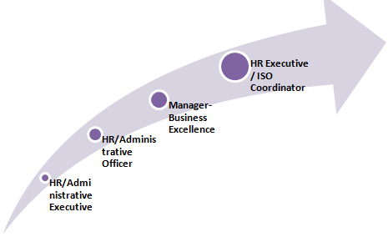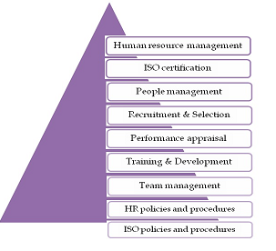

CORE COMPETENCIES

- Responsible for all HR functions, including: Strategic Planning, Organizational Development, Staffing, Training, benefits administration, Employee Relations, Management Development, and Performance Management.
- Ensuring the ISO policies and procedures are well defined and followed throughout the organization
- Management Representative for ISO 9001:2008, 14001:2004 and 18001: 2007

WORK EXPERIENCE

September 2016 to December 2016 with Alpha Data LLC, Abu Dhabi, UAE
HR Specialist
  - Complete HR process including Resource hiring, Induction, Training & Development, Performance Management, Exit formalities
  - Maintaining HR policies and HR Manual
  - Engage in Employee Engagement activities & programs
  - Ensure quality assurance through Internal Audits & External Audits for ISO 9001:2008
  - Legal expert in reviewing the documents and contracts of Alpha
  - Support in preparing document summaries & control legal corporate documents
  - Provide legal advice and opinion on legal matters to minimize exposure to liabilities and disputes
May 2014 to September 2016 with Al Injazat Technical Services (ATS), Abu Dhabi, UAE
HR Executive/ISO Coordinator

Responsibilities:
- Handle the recruitment process and hiring of all front line employees
- Prepare job description, offer letters, warnings and other employee related documents
- Responsible for the on boarding process of new employees, conducting orientation training to all new joinees, ensuring that all documents and procedures have been successfully completed as per UAE laws.
- Responsible for the payroll management and performance appraisal of all the employees in the organization.
- Meeting with employees to understand their grievances and recommend suggestions
- Initiate training plans and policies and support in organization’s training requirements and ensure training documents are updated.
- Act as the liaison with the Certifying Body on matters relating to the quality system
- Manage Quality Management System audit with in-house Internal Quality Auditors to verify that all activities are performed against the established or documented standard procedures.
- Monitor all identified non-compliances in the quality management system and evaluates effectiveness of the preventive and corrective actions.
Highlights:
- Appointed as the Management Representative for the ISO 9001:2008, 14001:2004 and 18001:2007 certification from May 2014 till date
- Conduction of ISO training to all the employees so as to ensure complete awareness among them.
- Handle PRO tasks including new visa, visa renewals, submission for Emirates ID and medicals for the employees (while PRO on leave)
November 2009 to May 2014 with PIT Solutions Pvt. Ltd, Technopark, Kerala, India
Last designated as Manager- Business Excellence

Growth Path:
Nov’09 to Jan’11 HR/Administrative Executive
Jan’11 to June ’12 HR/Administrative Officer
June’12 to May’14 Manager- Business Excellence

Responsibilities:

As Manager- Business Excellence
• Responsible for driving continuous improvements (maturity) into the processes and performance
• Maintain project performance measures on a regular basis to report to leadership on project status as required
• Collating data outlining areas of strength and areas of improvement based on analysis of results and business performance.
• Evaluating the effectiveness of improvement activities.
• Working with departmental teams on action plans to improve quality

As HR/Administrative Officer
• Coordination with Technical panel and understanding their requirements, defining job positions. Resourcing, screening and short listing resumes through various job portals
• Short listing the resumes based on desired skills and experience.
• Scheduling and arranging training while coordinating with external trainers and training programs.
• Compilation & processing of attendance data in attendance system.
• Designed Policies and Various HR Forms and Induction Program.
• Keeping track of Confirmation, Appraisals, and Increments of employees

As HR/Administrative Executive
- Assist the HR team in recruitment activities for the team
- Sourcing, screening, short-listing and briefing candidates about the clients & project requirements.
- Developing reports for senior HR Officers on staff sick leave, absences and holiday leave
- Interpreting and clarifying the companies HR policies & practices.
- Ensuring the department complies with all recruitment Policies, Laws, and Regulations.

CERTIFICATION

- Internal auditor certified for ISO 9001:2008, ISO 14001:2004 and OSHAS 18001:2007
- IRCA Lead Auditor training for OHSAS 18001:2007 from TUV NORD

ACADEMIC DETAILS

2009 MBA in HR and Finance from University of Kerala, India (76%)
2007 B.Com. from All Saints College, University of Kerala, India (74%)

PERSONAL DETAILS
Visa Status: Residence Visa (Company sponsorship)
Languages Known: English, Hindi & Malayalam
Date of Birth: 10/08/1986
Nationality: Indian
Marital Status: Married

