ENGR. ANWAR

Curriculum Vitae

CIVIL ENGINEER - ESTIMATION ENGINEER, QA/QC ENGINEER – PROJECT ENGINEER PROFESSIONAL

Qr Code :
ANWAR
Email: anwar.337547@2freemail.com
ESTIMATION ENGINEER CIVIL ENGINEER | PROJECT ENGINEER | QA/QC ENGINEER

PROFILE SYNOPSIS

- A resourceful civil engineer who is vastly experienced in engineering from the initial conceptual stage, through feasibility study and to detail.

- Physically fit and able to work on-site and at remote locations, willing to undertake any work of a technical nature that falls within ability and competence.

- Remarkable ability Design-Build Management, Project Plans & Documentation, Engineering Cost Estimates, Cross-Functional Team Supervision. Execute and deliver construction projects, mainly to residential villas & commercial warehouse.

- Solid record of health, safety and environmental focus when working on projects, and committed to personal and professional development.

- Well-developed oral and written business communication skills. Respected team leader, Motivator with exceptional interpersonal skills,

CORE COMPETENCIES
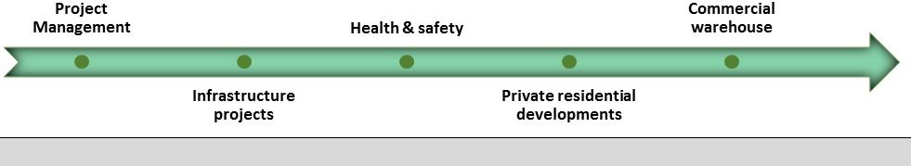

CAREER CONTOUR

Estimation Engineer (tender department) (Aug. 2016 -PRESENT)

ALTHARA, DUBAI ,UAE.

Civil Engineer (Jun. 2014 – Present)

KIT ENGINEERS &CO. (PRIVATE SECTOR)
Civil Engineer (Oct. 2013 - Jul. 2014)

PROJECTS

ASQALAN EXPERIENCE:

Project (BOQ):25 multi stories Residential & Commercial Buildings included shopping malls. BY: ADCE Project (BOQ):5 facilities building of Command of Military Works.

Project (BOQ):4 Infrastructure and Administration Buildings for CICPA. Project (BOQ): 20 Warehouses by different consultants.

Project (BOQ): More than 45 residential Villas by different consultants.

- Prepare BOQ as per specifications & drawing.

- Raise queries to the consultant to get clarification for discrepancies.
- Identify the scope of work pertaining to the tender and prepare tender summary.

- Segregate and assign drawings ,specification and BOQ required for suppliers &subcontractors.

- Assess subcontractor quotations and report to estimation manager.

- Receive tender documents and verify them for completeness.

ALTHARA EXPERIENCE:

Project: Commercial warehouses. Consultant: Expert Engineering Consultant Project: 9 Villas Al Khawaneej Dubai. Consultant: Proline Engineering Consultant.
Project: Multiple residential Villas & commercial warehouses Dubai. Consultant: Expert Engineering Consultant.

DOMAIN SKILLS

- Competent in all phases (Planning, execution and finishing) of building construction.

- Competent the design basis civil work (Tender calculations)

- Preparation of construction schedules of different projects & submittals of different projects

- Follow up government authorities E.g. DM, RTA for completion of project as per approved regulations.

- Responsible for the implementation of corporate/project procedures & instructions within assigned operations.

- Visit of sites, inspection of work done and report the progress of work to the project manager.

- Discussion with consultant according the site condition and drawing.

- Handling the construction lay out and map designing.

- Provides man-hour and material estimates for project proposals.

- Able to work under pressure and coordinate numerous activities while maintaining

- Quality teamwork by routinely collaborating with the project team.

- Appointing sub vendor & sub contractor and evaluate their performance.

- Prepare progress reports of construction performed by various contractors and upon completion of a given project, record final amounts of materials used in construction.
- Responsible for investigation and checking of the sites for the project.

- Competent in structural work. Maintain the daily progress reports.

- Discussion with consultant, manager, according the site condition and drawing.

- Competent to lead the development of the technical input for solicitations for part of civil contract scope, including the BOQ and the installation specifications.
- Prepare and submit all the Test Results for Final Acceptance to the Clients and consultant.

- Verification of as built drawings and actual bill of quantity for complete jobs.

- Performing different material tests by using BS standards.

- Competent to prepare mix design of concrete.

- Provides input to initial project schedule & supports regular maintenance of the civil part of the project schedule.

- Perform site execution, site control and implementation of drawings according to specifications. building layout and leveling work according to site conditions ,sub structure and super structure work according to drawings and executing finishing work.

ACADEMIC CREDENTIALS
- B.Sc. Civil Engineering, Mirpur University of Technology, AJK council Pakistan - 2013

- Diploma of Associate Engineering 2006-2009

TRAININGS & CERTIFICATIONS
❒ AutoCAD & DM Building Control System Training - 2007 & 2016

ACADEMIC CREDENTIALS

 B.Sc. Civil Engineering, mirpur university of Technology AJK council Pakistan - 2013

MEMBERSHIPS

- Society of engineers-uae

- Trakhees accreditation program

- Pakistan engineering council

KEY SKILLS
- Able to assist or instruct electricians and wiremen.

- Willing to be on a call out rota for emergency callouts.

- Strong decision-making skills and the ability to prioritize and plan effectively.

- Methodical approach to all tasks. Knowledge of Building Services.

- Ability and also willingness to work in all weather conditions.

- Excellent customer facing and communication skills.

IT SKILLS

- Proficient in Practical knowledge on operating Systems

- Microsoft Operating Systems

- AutoCAD

- Etab

- Matlab

- Primavera

- DM Bcs

PERSONAL DOSSIER

 Date of Birth: 16th June 1990
- Languages Known: English and Urdu

- License: Valid UAE driving license

 | Nationality: | Pakistani
 | Visa Status: | Employment UAE

