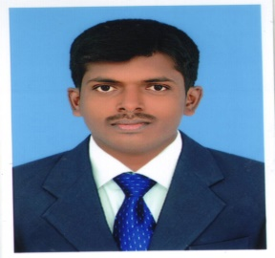
CURRICULUM VITAE

SIVAGNANAM
SIVAGNANAM.337562@2freemail.com

Objective:-

To grow in a leading organization, where I can contribute towards the growth of organization, which would not only offer me deep and diversified exposure but also enhance my skills, use of my experience for the achievements of organization goals and objectives.

Educational Credentials: -

- MBA (Finance & Marketing) Appeared in 2010-2012 from Rathinam College Arts & Science, Coimbatore, which is affiliated to the Bharathiyar University, Coimbatore.

- Bachelor of Commerce, (B.com): Appeared in 2007-2010 from Caussanel College of Arts & Science, Muthupettai, which is affiliated to the Alagappa University, Karaikudi.

Computer Proficiency

- MS Office
- Tally ERP 9

Projects Profile

PG Project (MBA) :
Title : A Study on Financial Statement with reference to
Craftsman Automation Pvt Ltd”
Organization : Craftsman Automation Pvt Ltd, Coimbatore.
Team Size : 2
Duration : 3 months

UG Project (B.Com) :
Title : Online portal for professional and enrolment system
Organization : SRM InfoTech
Team Size : 2
Duration : 4 months

Key Strength Areas:

- Finance & Accounts Operations
- Accounts Receivable and Payable Management
- Billing & Invoicing
- Bank & Supplier Reconciliation
- Monthly Accounts Reporting

Working Experience

- Ramanathapuram, Tamil Nadu, India.
Period : June 2012 to October 2016
Designation : Junior Accountant
Nature of duties:-
- Handle customers and their financial transactions
- Make Loan payments to customers against Jewel’s and vehicle after checking and validating documents. Check the availability of funds before making payments to customers
- Received and processed customer financial transactions, including deposits and loan payments
- Preparation of receipt and payment vouchers
- Maintains payroll information by collecting, calculating, and entering data.
- Disburses petty cash by recording entry
- Verifies vendor accounts by reconciling monthly statements and related transactions
- Manage the entire accounting/finance operations including finalization of accounts and preparing reports ensuring accounting standards, up to data maintenance of computerized accounts
- Perform physical verification of cash at the end of the day and reconcile with banking records.
Personal Information
Date of Birth : 15.01.1990
Sex : Male
Nationality : Indian
Marital status : Single
Languages known : English & Tamil
Visa Status: Visit Visa
Declaration
I hereby declare that the above furnished particulars are true and correct to the best of my knowledge and belief.

