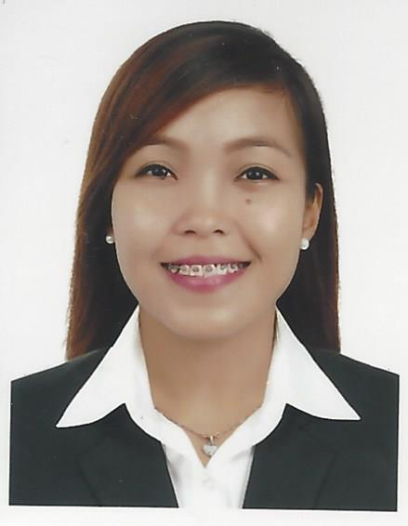

KRISTINE
KRISTINE.337570@2freemail.com
Registered Nurse

___________________________________________________________________________________

OBJECTIVE To work in an environment that motivates excellence, passion for work and loyalty towards the organization that will strengthen any personal character, which will enable me to become more competitive in my chosen field of endeavor.

PERSONAL PROFILE

Birth date : October 26, 1990
Gender : Female
Civil Status : Single
Citizenship : Filipino

EDUCATIONAL QUALIFICATIONS

Post Graduate:
Cebu Normal Univesity
Master of Science in Nursing Major in Medical Surgical Nursing
(2012-2014)
Tertiary :
University of Cebu-Banilad
Bachelor of Science in Nursing
(2008-2012)

Board Exam Taken: Philippine Nursing Licensure Exam (June 30-July 1, 2012)
Remark: Passed

WORK EXPERIENCE

Nurse

January 23, 2013 to May 10, 2013
Nurse Trainee
St. Vincent General Hospital
- Delivered effective and efficient care to the patients. Performed basic and advanced competencies of a nurse. Served duty in Pedia Ward, Medical-Surgical Ward and Intensive Care unit (ICU).

June 10, 2013 to September 16, 2013
Operating Room Nurse Trainee
St. Vincent General Hospital
- Assisted the surgeons on their operation
- Conducts pre- and post-operative education
- Serves as the communication liaison to family and members of the operating team
- Takes and monitors patients’ vital signs

Technical Support Professional

November 11, 2013 to March 21, 2015
Technical Support Professional
Convergys Philippines Inc.
- Interact with customers to provide and process information in response to inquiries, concerns, and requests about products and services
- Gather customer’s information and determine the issue by evaluating and analyzing the symptoms

Staff Nurse
May 2, 2015 to April 16, 2016
Medical-Surgical ward nurse
St. Vincent General Hospital
- Provide medications and injections as prescribed by the doctor.
- Monitor vital signs like BP, Temperature, and Pulse and record it.
- Refer any changes in patient's status or untoward reaction to the doctor.
- Monitor, analyze and record urine and stool output.
- Assist doctors during treatment.

Health Care Technician
September 2016-present
Home Care Nurse
Enaya Home Nursing Services, Belhoul Lifecare LLC
- Provides medical and personal care to individuals who are chronically ill, disbabled or suffering from cognitive impairments.

