RESUME

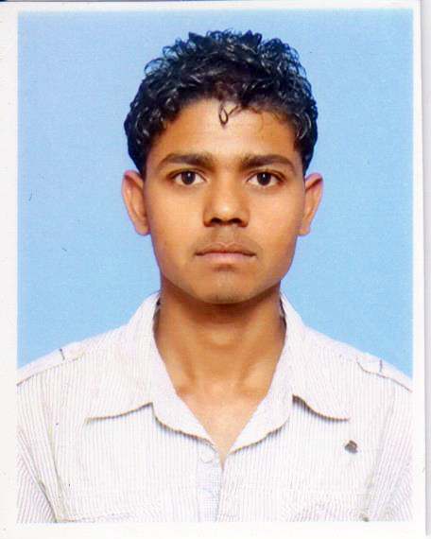
GURPREET

Email :- gurpreet.337625@2freemail.com

OBJECOTIVE
- To prove my worth in whichever field I go into.
- To enhance and increase my professional skills by working in a Result Oriented concern.

ACADEMIC QUALIFICATION:
- Metric from C.B.S.E (New Delhi).
- 10+2 from P.S.E.B (Mohali).

PROFESSIONAL QUALIFICATION:
- One year diploma in Computer Application from International Technology Management Education.

COMPUTER KNOWLEDGE:
- Basic Knowledge of Computer, Internet, MS office, & some software knowledge also.

EXPERIENCE:
- Six month experience in Dera Baba Nanak (Gram Penchant Bhawan) as a computer operator.
- Six month experience in Adhar card Operator

INTEREST:
- Reading Books
- Listening Music
- Achieves the goal in my life.

LANGUAGE KNOWN:
- English, Hindi& Punjabi

PERSONAL DETAILS:
Date of Birth : 11 Oct 1992
Marital status : Unmarried
Gender : Male
Nationality : India

