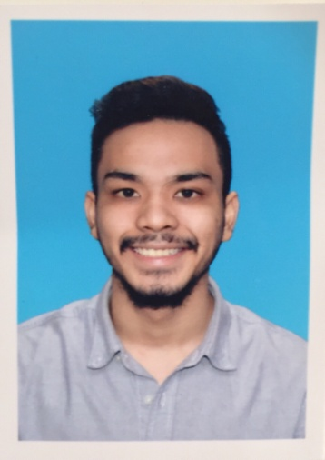
Objective: To learn & function effectively in an organization until I develop my full potential. Dedicate myself to achieve excellent outcome in any tasks or responsibility given to me in hopes to reach the company’s goal. Hope for a chance to be employed by a respectable company or institution that can help me increase my knowledge and sharpen my skills.

PERSONAL INFORMATION

- Name : Ahmed
- Age : 23
- Date of Birth : 31st October 1994
- Gender : Male
- Nationality : Malaysian
- Height : 182 cm
- Weight : 74 kg
- Race : Malay
- Religion : Islam
- Marital Status : Single
Email Ahmed.337635@2freemail.com

b
EDUCATIONAL BACKGROUND

- 2001 – 2006 (UPSR) : Sekolah Rendah Islam Integrasi Masjid Darul Ehsan,
Result : 2A 3B
- 2007 – 2009 (PMR) : Sekolah Menengah Kebangsaan Seksyen 9, Shah Alam
Result : 5A 3B
- 2010 – 2011 (SPM) : Sekolah Menengah Kebangsaan Seksyen 9, Shah Alam
Result : SPM Cert.pdf (2A , 1A- , 4B+ , 1B , 1C+)

CAREER SUMMARY

- Position in last employment: Sales & Marketing Executive
- Name of recent Company: Agri Asia Group Sdn. Bhd.
- Duration of working in last employment: December 2014 – May 2016
SKILLS

- Can speak/write English & Bahasa Malaysia fluently and well. Excellent communication skills and have high confidence to interact/communicate with people.

- Ability to persuade people in order to achieve sales. Always think outside the box. High attention to detail. Good time management skills.

- A fast learner. Easy to learn and gain new skills. High critical thinker with effective researching skills proven through work experience. Eager to increase knowledge and sharpen skills.

