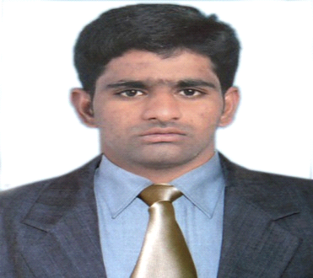
CURRICULUM VITAE
System/Network-Administrator
VINAYAKREDDY
E-Mail: VINAYAKREDDY.337670@2freemail.com

- Philosophy and Career Goal :
- I am extremely passionate about self-development, customer service and building relationships based on
Value and trust! I believe that opportunities will come to those who strive for excellence and are committed to what they do. With these qualities, I would like to create a career path in IT Network/Systems Administrator.

- Career Summary :
- My Role is to provide 24*7 System/Network administration support and other Technical Support.
- 8 months experience working as a System/Network administration Environment.

- Education :
- Bachelors of Information Technology from Jawaharlal Nehru Technological University, India.
- Board Of Intermediate Education from Osmania University, India.
- School Of Secondary Education from Boardof Secondary Education, India.

- Knowledge In Microsoft and Cisco :

- Installing & Configuring of MicrosoftWindows Server Operating System (Windows Server 2003, 2008 & 2012), Client Operating System (Widows XP 98, 2007& 2008) .
- Installing Active Directory, configuring client & member servers, permissions.
- Implementing Group policies, profiles and Disk Quota.
- Installing and Configuring TCP/IP Services like DHCP, DNS.
- LAN and WAN network support.
- Networking (TCP/IP), Switching and Routing & Network Security.
- Routing Protocols – RIP v1/v2, EIGRP, OSPF and Policy Based Routing.
- LAN/WAN Technologies, Frame Relay, Ethernet and VLANs.
- Performed Network Address Translation (NAT).
- Cable Crimping and Connecting.
- Ms Office 2003 & 2007.

- IT Experience Details :

First Organization - KCLINK TECHNOLOGIES oct 2015 – june 2016.
- Role - System Administrator.
- Work Experience - 8 Months.

- Responsibilities :
- Managing exchange server 2007, Installation and configuration of exchange server 2007 and 2010.
- Configuration of mailbox and Recipients (Mailbox user, Mail enable user and distribution group).
- Configuration of client (Outlook web Access, MS outlook, Outlook Express).

- Backup and Recovery of E-mails using MS outlook, Outlook Express.
- Managing Mailbox Permissions, Storage Groups, Database and public Folder.
- Monitoring and maintaining LAN &WAN networks.
- Developing and monitoring procedures for server backups.
- Implementation and management of VLAN’s on the switches.
- Network connectivity troubleshooting, ping, and telnet.
- Providing support for the MS Office applications (MS Word, Excel, PowerPoint and Outlook).
- Installing and troubleshooting all kind of software’s as per the requirement.
- Maintaining different antivirus for servers and clients.
- Configuration and troubleshooting of Wi-Fi Router.
- Assembling of desktops, installation and configuration of Operating systems, Network printers, PCs etc.
- Rectification of system hardware problems like internet connectivity, Printer connectivity.
- Personal Details :

- Date of Birth : 16June 1992.
- Visa Status : Visit Visa(10-02-2017.
- Interests : Cricket, watching tv.
- Languages : English, Hindi & Telugu.
- Availability : Immediate.

I DECLARE THAT INFORMATION STATED ABOVE IS TRUE TO THE BEST OF MY KNOWLEDGE

