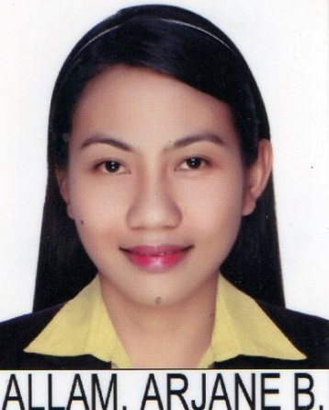
ARJANE, RRT
ARJANE.337690@2freemail.com
__________________________________________________________
OBJECTIVE:
Desire a radiologic technology position, where I may be able to utilize my techniques and knowledge in performing diagnostic radiology procedures and producing high quality radiograph.

KNOWLEDGE AND SKILLS:

Can perform diagnostic procedures utilizing x-ray, mammography and basic learning of Ct-scan procedures.
Sonographer/ultrasound technologist
Take patient histories and explaining the procedure feature.
Assuring quality assurance and quality control.
Knowledgeable regarding to exposure factors and patient care.
Committed in continuing personal and professional development.
Computer literate

EDUCATIONAL ATTAINTMENT:
Bachelor of Science in Radiologic Technology
Academic Distinction
Medical Colleges of Northern Philippines 2009-2013
Alimanao Hills Peñablanca, Cagayan, Philippines

PROFESSIONAL LICENSE:
LICENSING BODY: Professional Regulation Commission
PROFESSIONAL STATUS: Registered Radiologic technologist
REGISTRATION NUMBER:

LICENSING BODY: HEALTH AUTHORITY ABU DHABI (HAAD)
PROFESSSSIONAL STATUS: Registered Radiologic Technologist
REGISTRATION NUMBER: HAAD
REGISTRATION DATE: SEPTEMBER 25, 2016

TRAINING ATTENDED:

Diagnostic Ultrasound
First Philippine Imaging and Diagnostic Institute Nov.7,2016-Jan.20,2016
1200 Edsa Corner Seminary Road,Munoz Quezon City.

Junior Internship
East Avenue, Medical Center (Tertiary Level)
Diliman, Quezon City, Metro Manila, Philippines June-November 2012

Senior Internship
Jose R. Reyes Memorial, Medical Center (Tertiary Level)
Rizal Avenue, Sta. Cruz, Metro Manila, Philippines November-March 2013

WORK EXPERIENCE:

August 4, 2014 to August 6,2016 Laoag City, Multi-Medical, Diagnostic, Centre
Brgy.7B, Laoag City, Ilocos Norte, Philippines

July 24, 2013- February 14, 2014 Saint Martin de Porres Hospital
San Antonio, Candon City, Ilocos Sur, Philippines

JOB DESCRIPTION:

Performed Ct-scan procedures such as cranial, abdomen, chest, orbital, and paranasal sinuses.
Mammographer technologist taking craniocaudal, mediolateral oblique and magnification view upon requested by the physician.
Assisting the radiologist in ultrasound procedures like whole abdomen, KUB, HBT and others both in geriatric and pediatric patients; transvaginal, BPS and pelvic in obstertric.
Performed general radiographic procedures, traumatic, non-traumatic, geriatric and pediatric patients.
Responsible in screening and assessing patients and their clinical requirements for every procedures
Introducing contrast media under the supervision of the radiologist.
Responsible for preparing dye mixtures.
Maintaining accurate selection of exposure factors using caliper.
Can process radiographic film manually and automatically.
Performed the maintenance of the automatic processor and changing the solutions.
Protects patients by adhering infection control policies and follow protocol in drug administration primarily introducing contrast media in case of any reactions.
Document patient’s history.
Maintained finalized radiologist dictation report.
Films and other imaging materials inventory engaged.

ON GOING ULTRASOUND TRAINING

PERSONAL INFORMATION:

Gender Female
Civil status Single
Age 24
Weight 50kg
Height 5’3”1/2
Birthdate September 10, 1992
Birthplace San Francisco, Baggao, Cagayan
Nationality Filipino
Religion Born Again Christian
Current Location San Francisco, Baggao,Cagayan, Philippines
Language Spoken English, Tagalog

I hereby certify that above information are true and correct to the best of my knowledge and belief.

