CURRICULAM VITAE
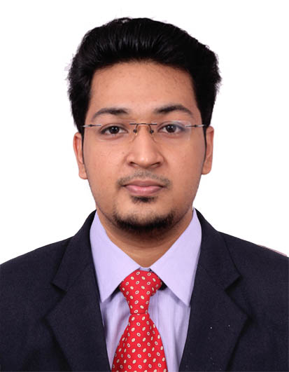
PERSONAL DETAILS:

Name JEFFREY
Email JEFFREY.337696@2freemail.com
Gender Male
Date of Birth 07-12-1992
Marital Status Single
Nationality Indian
Languages Known English, Malayalam,Hindi (Read,Write,Speak)
Kannada,Tamil (Speak)

PROFESSIONAL OUTLOOK:

Seeking a challenging career to reach the position which provides me avenues for learning and encourages individual growth and contribute to an organization of repute, both for professional as well as organizational goals.

ACADEMIC QUALIFICATIONS:

Examination | Institute | University/Board | Grade | Year of Passing
Bachelor of  Clinical Optometry | School of Allied health sciences,  Manipal | Manipal University | Passed with 2nd class | 2014
12 | Marthoma Senior Secondary School, Kozhencherry | CBSE | Passed with 1st class | 2010
10 | Marthoma Senior Secondary School, Kozhencherry | CBSE | Passed with 1st class | 2008

TRAINING & EXPERIENCES:

PROFESSIONAL INTERNSHIPS | DURATION
- Kasturba Medical College, Manipal  - Nethradhama eye hospital, Mangalore  - Lawrence & Mayo Opticals, Mangalore  - Clinical Optometry Internship in NARAYANA NETHRALAYA super specialty eye hospital & post graduate institute of ophthalmology, Bangalore | August-November 2013  December 2013  January 2014  February-August 2014

WORK EXPERIENCE:
- Consultant Optometrist at Giridhar Eye Institute (NABH & ISO 9001-2008 Certified Eye Hospital), Kochi, Kerala from 28th September 2015 to 5th December 2016
- Consultant Optometrist at St. Thomas Mission Hospital, Kattanam, Alappuzha, Kerala from 9th September 2014 to 10th September 2015.
- Part-time Consultant Optometrist at Maruthi Opticals, Charummood, Alapuzha, Kerala from 1st September 2014 to 25th September 2015.

PROFESSIONAL LICENSE:
- Valid DHA (DUBAI HEALTH AUTHORITY) License - Eligibility ID: DHAE486284

CLINICAL SKILLS & ATTRIBUTES SUMMARY:
- Good communication & Interpersonal skills
- Can perform comprehensive eye examination
- Slit Lamp examination for Optometry practice.
- Objective (Dry and Wet Retinoscopy) and Subjective Refraction utilizing Duochrome and Jacksons cross cylinder to diagnose vision related problems.
- Contact lens fitting, Assessment and Dispensing of Soft, RGP and Toric lenses and specialty fittings including Rose-K, Hybrid, Scleral lenses, Presbyopic and Colour vision contact lenses.
- Colour Vision and Stereopsis Evaluation
- Squint evaluation and quantification

- Performs Visual Field Analysis (Confrontaion & HFA),Auto-Refractometer, Keratometry(both automated and manual), Applanation, NCT, Tonopen and Schitoz tonometry, Fundus Photography, Potential Acuity Meter, Synaptophore, OCT, Pupillometer, Exophthalmometer.
- LASIK Workup includes Topography, Pentacam & Pachymetry.
- Pre and Post Cataract workups includes A-Scan(Contact and Immersion),I-Trace,I-Design, Lenstar, Varion, Bio Medix
- Low vision & Rehabilitation of Blind & Visually Impaired
- Ocular Surface Evaluation, Diplopia charting & Hess charting.
- Electronic Medical Records

PROJECT SUBMITTED:
- A Comparative Anthropometric study of Dravidian and Mongoloid ethnic races present in Manipal University

PROFESSIONAL MEMBERSHIPS:
- Member of INDIAN OPTOMETRIC ASSOCIATION (IOA) - Registration No. LM-02511/016
Life time membership.

- Member of OPTOMETRY COUNCIL OF INDIA (OCI) - Registration No. 06 2015 817

WORKSHOPS & CAMPS:
- Attended Workshops on Optometry Update, Varilux Academy training and Contact lens essentials for Beginner.
- Attended Rose K training lecture given by Dr Paul Rose.
- Attended Workshop from Essilor for Lens Manufacturing, Moulding, Surfacing, Polishing and Dispensing.
- Attended Progressive addition fitting training from Varilux Academy
- Attended community Eye screening programs in rural areas in and around Manipal
- Attended Children Eye screening for school going children for age of 3 yrs to 16 yrs of Government, Private & Residency schools conducted by the Sarva Shikshana Abhiyana, Karnataka.
- Exposure to outdoor patients through Camps.

PASSPORT DETAILS:
- Date of Issue: 22-09-2014
- Date of Expiry: 21-09-2024
- Place of Issue: Trivandrum

INTERESTS & HOBBIES:

- Music
- Books
- Indoor & outdoor games
- Travelling and meeting new people

EXTRACURRICULAR ACTIVITIES:

- Actively participated in several sports events (Cricket, Football, Badminton and Chess) both in School and College levels and represented Manipal College of Allied Health Sciences in all the above sports in all-academic years.
- Participated in several onstage and offstage events for arts day both in school and college levels. Represented college for UTSAV (an event conducted by university) and KAYAL.

DECLARATION:
I hereby solemnly affirm that all information furnished here are true to best of my knowledge.

