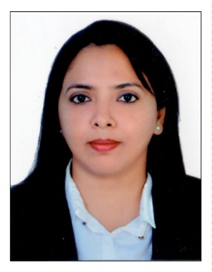
Shagufta
Email: shagufta.337697@2freemail.com

PROFESSIONAL SUMMARY

I have worked well in challenging environment and have experience in Leadership roles.
Loyalty and continuous strive for excellence are my top Qualities.

SKILL HIGHLIGHTS

Excellent verbal and written communication skills, including ability to effectively communicate with
Internal and external customers.
- Customer service expert & creating memorable experience.
- Ability to work independently and meeting the deadlines, while maintaining a positive attitude.
- Overcoming difficult service situations.
- Computer literacy and good typing skills.
- The ability to work as a part of the team. ``

WORK EXPERIENCE

Administration & HR Asst: Sherwood’s International Properties LLC – (Dubai-Dec’2015 to Present)

- Answering all Incoming Calls and capturing the client’s details on CRM.
- Provide full administrative support including Internal Memos, creating & maintaining filling systems, copying, distribution of mails, managing emails, travel arrangements, preparing reports and personal request.
- Managing and updating all the Portals (Propspace, Dubizzle,Just Property & Property Finder)
- Generating weekly Reports.
- Preparing Tenancy Contract for Leasing of Residential Units, Villas & Commercial spaces.
- Offer support to all Real Estate related activities for Multiple Projects.
- Full maintenance checking furniture, suppliers, cleaners, storage & refreshments.
- Asst HR: - managing leave records of all the employees (Sick Leave, Annual Leave) also keeping a track of their daily activities.
- Have Contacted potential candidates, screened them and set up Interviews with the Senior Managers and also assisted with the paper work.

Achievements: - within a short period I have excel in my position, promoted as an acting HR.
Was also a part of Dubai Property Show and couple of event (Spinney’s, Open House for different Projects.)

Customer Advisor: Hutchison 3Global services-India (Mumbai)
(November’08 to Feb’13) & (August’13 to October’14)

- Providing technical assistance and services to Business customers (3 Biz Care)
- Training new agents within the team for customer service (Super Buddy)
- Providing service to customers.(Vodafone Care)

Promoted as a Quality Analyst: First Source Solutions Ltd-India (Mumbai)
(March 2008to November’08)
- Monitoring Calls.
- Coaching and giving Feedbacks to Advisors.
- Preparing Reports for the Operations Floor.

Senior Customer Advisor: First Source Solutions Ltd –India (Mumbai)
(12Aug ’04 to 26th march ’08)
- Providing technical assistance and services to customers for UK based (Talk Talk Broadband)
- Training new agents within the team for customer service and technical support.
- Completely supported migration and backfill batches for Talk Talk which includes Briefing, Listening, to calls and giving the feedback.

CORE COMPETENCIES

- Treat customers courteously.
- Respond to customer request in a timely manner.
- Take responsibility to resolve customer complaints.
- Consider both short and long term interests of the customer in making service decisions.
- Proactively identify customers need.

ACHIEVEMENTS
- Top Performer of the month award
- Star of the month award
- Call of Fame.

PERSONAL DETAILS:

Marital Status : Married
Nationality : Indian
Visa Status : Employment

EDUCATION QUALIFICATION:

Diploma in Advertising and Public Relations 2003
B.A Passed from Mumbai University April 2002
HSC Passed from Maharashtra Board March1999
SSC passed from Maharashtra Board March 1997

LANGUAGES KNOWN:-

Read, write and speak
- English
- Hindi

HOBBIES:

Listening to old soft Music, Travelling and writing Ghazals.

___________________________
Signature

