RESUME

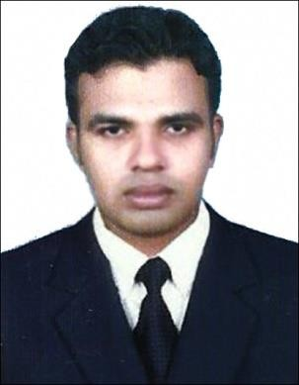
HASHIM
Deira,Dubai
Email: hashim.337707@2freemail.com

Career Objective:

A reliable and self-motivated person with ability to multi-task and work under pressure. I take pride in being a hard working, dependable and dedicated employee. I promise that I would do, to the best of my ability and prove to be an asset to your organization at all times.

Strength:

- Self motivated, Multi lingual, Hard working with rich experience in handling any kind of work.
- Take-charge professional with exceptional follow-through abilities, belief in professional integrity, company loyalty and strong motivator.
- Excellent interpersonal analytical and negotiation skills.
- A dedicated individual who possesses an excellent problem solving, coordination, management, organizational skills.
- Can handle multiple tasks effectively and very much flexible with time.
- Possess excellent organizational skills and can work well independently.

Work Experience: -
Worked as an Accountant in Safath Agency, Calicut, Kerala, India. (Nov 2011 – Dec 2012)
Worked as an Accountant in Saju Brothers Traders Pvt. Ltd, Vatakara, Calicut, Kerala, India (Jan – Dec 2013)

Worked as an Archives Clerk in Manelco Electrical Engineering ,qusais .Dubai
(march 2014- to ………..)

Educational Qualifications:

Bachelor of Commerce from Calicut University, Kerala, India Plus Two (Higher Secondary Board of Examination, Kerala, India)

Computer & Software Skills:

Accounting Packages: Tally, Peach Tree, Quick Books, Trade Easy

M S. Office Packages (Word, Excel, Powerpoint (etc) Internet, Email Applications and Web Browsing

Personal Details:

Date of Birth : 3rd Oct 1988
Nationality : Indian
Marital Status : Single
Visa Status : Job Visa
Languages known : English, Hindi, & Malayalam

Declaration:

I hereby declare that the above written particulars are true and correct to the best of my knowledge and belief.

Hashim

