Curriculum vitae  KEVIN  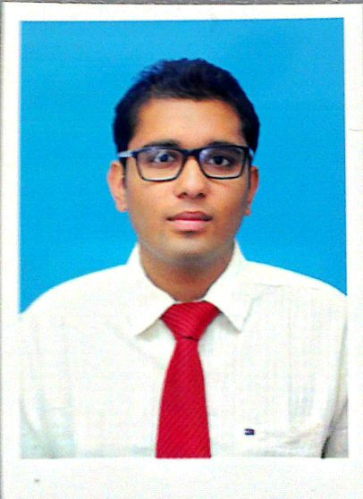  Personal Details  Date of Birth :  30th APRIL 1993  Sex :  Male  Nationality:  Indian  Marital Status:  Single  Email :  KEVIN.337712@2freemail.com  Languages Known:  Malayalam, Hindi, English& Tamil  Hobbies:  Playing chess, football, trekking. | Career Objective :  Seeking a position to utilize my skills and abilities in Mechanical  field that offers professional growth while being resourceful, innovative and flexible.  Work Experience:  - Worked as sales and services incharge at lanson Toyota Chennai, from March 2015- December 2015  Educational Qualification:  - GRADUATE IN MECHANICAL AND PRODUCTION ENGINEERING With CGPA(Cumulative Grade Point Average) of 6.8fromSATHYABAMA UNIVERSITY, CHENNAI.  - Class XII (HSE) from ZION Matriculation Higher Secondary School under State board of tamilnadu with 72%  - Class X (ICSE) from Kodaikanal public School under icse from 2007-2008 with 69%  Professional Experience:  Industrial exposures:  - Industrial visit at jeepeer steel  - Industrial visit at Hyundai moboic  - Fenner Industries ·  - Win Wind ·  Technical Software Skill Set :  - Technical Software : Autocad, Ansys, pro E.  - Computer Knowledge : Microsoft Office tools including  Word, Excel, Power point.  Key Skills :  - Ability in Mechanical Designing  - Producing Innovative Ideas  - Team Worker.  - Management Efficiency  - Good coordination  - Ability to work under pressure.  - Perseverance and Motivation  - Organization.  - Strong verbal and personal communication skills  Flexibility and adaptability
Academic Projects :

Title : PERFORMANCE ANALYSIS OF HORIZONTAL
SINGLE AXIS TRACKING SYSTEM IN SOLAR SYSTEM.

Description : The purpose of this project is to design a cylindrical
roller bearing and do the performance analysis of single axis. In the
existing system there is lot of noise, friction, wear and tear that is created. In order to overcome such problem a bearing was introduced between the moving parts. A comparative study was carried out to see if the existing system had more efficiency or the new design had more stability and better performance

Declaration :
I hereby declare that the above mentioned data are true and best of my knowledge.

Place:
Dáte

