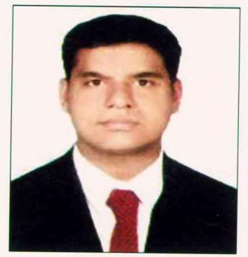
SAHAYA
SAHAYA.337720@2freemail.com
Accountant

CAREER OBJECTIVE:

Seeking a position in Accounts & Finance with a reputed organization where my potential matches the organizational growth and contributes for the achievement of my career and equip myself with rich skills, hard work.

CAREER PROFILE:

- 7+ years experience in Accounts with Food Industry in UAE
- Hold Master of Science (M.Sc., Chemistry)
- Knowledge in Focus & MS Office applications
- Hard working, Proficient, prearranged and detail-based professional with extensive knowledge in accounting works
- Hold strong logical and crisis handling skills, with the aptitude to formulate well planned decisions
- Highly dependable, cautious, principled and loyal
- Original in the completing projects, efficient in multi-tasking and submitting projects within deadline periods
- Team Management Skill

EXPERIENCE:

Chief Accountant, M/s. FIT FRESH LLC (Albwardy Group), Dubai (7+ years).

- Accounts Payable for more than 200 suppliers
- Responsible of Accounts Receivables
- Verifying Journal Entries, Debit Note & Credit Note
- Processing of Salary in WPS and Bonus Payment. Commission and Bonus Calculation and accruals
- Calculate Annual Leave Salary around 300 staffs
- Preparing Monthly Balance Sheet and P&L account
- Fixed Asset Management
- Reconciliation of bank statements
- Cash Flow Forecast
- Review and Update of Debtors and Creditors Ageing Report
- Handling Petty Cash in Daily Basis
- Foreign Currency Exchange Differences Revaluation
- Calculation of Term loan Interest
- Deposit Entry and refund entry ( Electricity & water, Immigration deposit, Security Deposit, Customs deposit)
- Supervising Sales invoice team & purchase invoice team
- Control and manage all accounting records including source documents.
- Monitoring Inventory, Office Stock and other necessary
- Handling Financial Audit
- Visa Processing
- Leading, Identifying the team and reporting to the management
- In addition to the above, managed the Logistics In Charge Activities during absence of the In Charge

ACADEMIC QUALIFICATION:

- Master of science in Chemistry ,India, 2007-2009
- Bachelor of Education, India, 2004 - 2006

TECHNICAL QUALIFICATION:

- Focus 7 software Accounting in system
- Windows 2007, XP, Internet & outlook
- M.S.Office

EXTRA CURRICULAR ACTIVITIES

- Volunteers’ Coordinator in St. Mary’s Catholic Church, Tamil Community, Dubai during 2013 – 2015
- Participated Cricket Tournament among Al Bwardy Group

PERSONAL PROFILE

Date of Birth : 15-07-1982

Gender : Male

Marital Status : Married

Languages Known : English, Tamil, and Malayalam

Nationality : Indian

VISA Status : Employment Visa

DECLARATION:

I do hereby declare that the particulars of information and facts stated herein above are true, correct and complete to the best of my knowledge and belief.

