Anusree  Anusree.337727@2freemail.com | 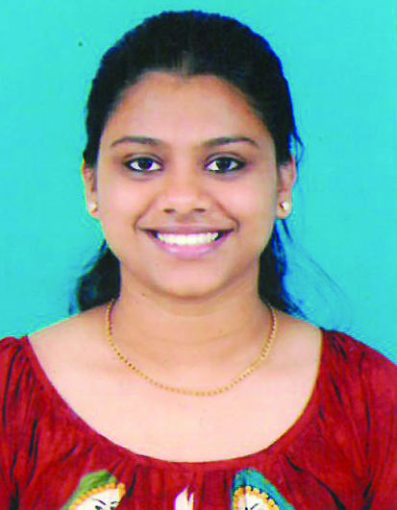

Career Objective:
To obtain an entry-level position as a Software Engineer with your company, allowing me to utilize my education, innovative ideas and internship experience while gaining valuable work experience in a team oriented environment.
Academics
Institution | Course | Percentage/CGPA | Year of Passing
Vivekananda College Of  Engineering & Technology | B.E(Information Science) | 65% | 2016
ST Philomena's PU College | P.U.C | 68% | 2012
ST Victor's Girls' High School | SSLC | 61% | 2010

Project Details
- Project Title: One Touch Alarm System For Women’s Safety Using GSM
Description: This project was to design and fabricate a gadget that provides an advantage of personal security system.Unit testing was done for the same.
Tools used: Embedded C ,Arduino 1.5.7
Duration: 1 Year
Contribution: Involved in coding, writing test cases,executing test cases,logging defects,preparing test reports.
Team Size: 4 members.
Technical Competencies
Operating Systems : Windows XP/7, UNIX.
Programming Languages : C, C++, Java, Microprocessor 8086 Assembly, SQL, HTML, CSS, Javascript
Tools : SQL Server Management Studio, NetBeans , JUnit
Database : Microsoft SQL.

Training participated/Certification
- KELTRON Internship Certificate
- Participated in the Linux Workshop.
- Participated in Software testing and PHP training programme.
- Undergone Training in JAVA from Nava infotech Services Private Limited , Kochi.
Knowledge in JAVA:
- SQL server
- Core java
- Servlets
- jsp
Extra Curricular activities
- Won prizes in extracurricular activities like speech competitions,skit ,dance
- Participated in taluk level Shuttle and Karate competition.
- Presented a seminar on “Cloud Robotics and Automation”.

Hobbies
Playing Shuttle, karate

Personal Details
Date of Birth : 7th September 1994
Nationality : Indian
Marital status : Single

Passport Details:
Date of Issue : 10/12/2015
Date of Expiry : 09/12/2025

I hereby declare that, all details mentioned above are true to the best of my knowledge and I bear the responsibility for the correctness of the above mentioned particulars.

